**Kubernetes- Application Lifecycle Management**

**Rolling Updates and Rollbacks**

***Updates and Rollbacks - Deployment***

- When you first create a deployment, it triggers a rollout. A new rollout creates a new deployment revision

- In the future, when the application is upgraded which means the container version is updated to new one. A new rollout is triggered and new deployment revision is created. This helps to keep track the change made on application and rollback to previous version of deployment if necessary

kubectl rollout status deployment <deployment name> ; status of rollout trigger

kubectl rollout history deployment <deployment name> ; show revisions and history of deployment

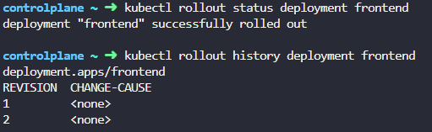

spec:

minReadySeconds: 20

progressDeadlineSeconds: 600

replicas: 4

revisionHistoryLimit: 10

selector:

matchLabels:

name: webapp

strategy:

rollingUpdate:

maxSurge: 25%

maxUnavailable: 25%

type: RollingUpdate

template:

metadata:

creationTimestamp: null

labels:

name: webapp

spec:

containers:

- image: kodekloud/webapp-color:v2

imagePullPolicy: IfNotPresent

name: simple-webapp

ports:

- containerPort: 8080

protocol: TCP

resources: {}

terminationMessagePath: /dev/termination-log

terminationMessagePolicy: File

dnsPolicy: ClusterFirst

restartPolicy: Always

schedulerName: default-scheduler

securityContext: {}

terminationGracePeriodSeconds: 30

When trigger new rollout or rollback, deployment creates new replicaset and remain old replicaset in the system

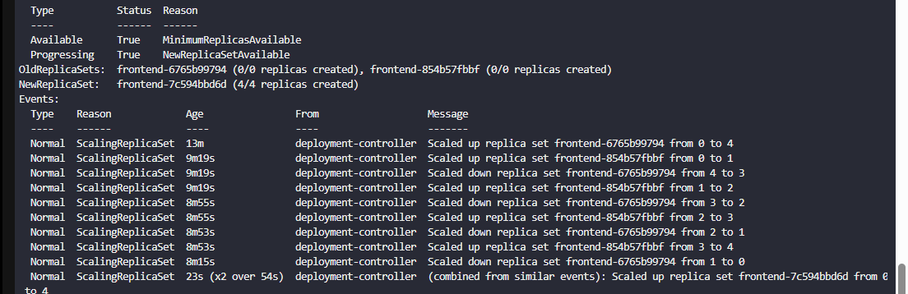

<https://www.techopsexamples.com/p/kubernetes-upgrades-how-not-to-mess-up>

***Deployment strategy***

*Recreate strategy*

- If the deployment has 5 replicas, it destroys all replicas at once and create a new replicaset with required replicas with the newer version. The issue is that during the period of deletion and recreation of pods, there is a downtime for users are not accessible the application

- Event in describe command indicates that old ReplicaSet is scaled down to 0 first and then new ReplicaSet is scaled up to 5

- When rollout happens in recreate strategy, it shows 502 bad gateway error on web app

*RollingUpdate strategy*

- The default deployment strategy if you don’t specify explicitly

- Take down older version and bring up newer version on pod one by one. Hence no downtime experience to application and upgrade is seamless.

- Event in describe command indicates that old ReplicaSet is scaled down one pod at a time, simultaneously new ReplicaSet is scaled up one pod at a time.

- We can specify how many pods in ReplicaSet should be unavailable at a time using ***RollingUpdate*** parameters in RollingUpdateStrategy

-You may update deployment exactly for updating application version, updating docker container use, updating labels, updating the number of replicas

kubectl apply -f deployment-definition.yaml ; update new deployment

kubectl set image deployment <name of deployment > <current container name>=nginx:1.9.1 ; set new image version in existing deployment definition file. You can set image on multiple containers in same command

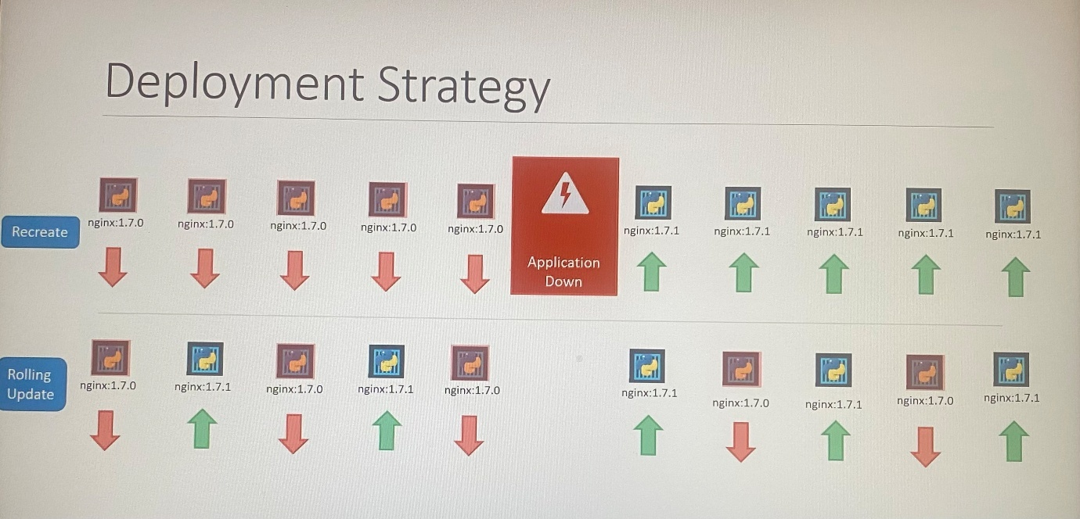

![- : describe deployment myapp-deployment 
myapp-deployment 
lome : 
default 
-reationlimestamp: Sat, O mar 2018 17:01:55 +0800 
7.1 
abels•. 
Innotations: 
elector: 
eplicas : 
trategyType: 
•linReadySeconds: 
od Template: 
opp=myapp 
type—front -end 
deployment. kubernetes. io/revision=2 
kubectl. kubernetes. io/last -applied : "apps/vIU , "kind" : "Deployment" , 
kubernetes. io/change-cause=kubectl apply --filenane=d: \Mumshad 
type-front-end 
5 updated | 5 total | 5 available I O unavailable 
Recreate 
Files\Goog1e Drive\Udemy\Kuberne1 
C : \kubernetes >kubectl 
I lame: 
tlamespace: 
creation Timestamp: 
Labels: 
Annotations : 
Selector: 
Replicas: 
StrategyType: 
hinReadySeconds: 
Roll ingUpdateStrategy : 
Pod Template: 
Labels : app—myapp 
describe deployment myapp-deployment 
myapp -dep loyment 
default 
sat, 03 Mar 2018 +0800 
app=myapp 
type-front-end 
deployment. kubernetes. io/revision=2 
kubectl. kubernetes. io/last-applied : "apps/vl " "kind" : "Deployment" , "metadat. 
kubernetes.io/change-cause=kubectl apply --filename=d: \Mumshad Files\GoogIe 
type-front-end 
desired updated | 6 total I a available | 2 unavailable 
Rollin Update 
25% max unavailable, 25% max surge 
Labels: 
app=myapp 
type—front-end 
Containers: 
nginx -container: 
type—front -end 
Containers: 
nginx•container: 
image: 
Port : 
nginx:l- 
cnone> 
Image : 
Port: 
nginx 
cnone> 
Environment: <none> 
Environment: cnone> 
mounts : 
Volumes: 
. onditions : 
Type 
Available 
Progressing 
)1dRepI icaSets : 
leuRep1icaSet: 
cnone> 
(none > 
Status Reason 
True MinimumRepIicasAvaiIabIe 
True NewRep1icaSetAvaiIab1e 
«none» 
myapp-deployment-54c7d6ccc (5/5 replicas created) 
Mounts : 
Volumes : 
Conditions : 
Type 
Available 
Progressing 
IdRepIicaSets : 
UewRepI icaSet : 
<none> 
Status Reason 
True MinimumRepIicasAvaiIabIe 
True ReplicaSetUpdated 
myapp-depIoyment-67c749cS8c (1/1 r- 'licas created) 
myapp-depIoyment-7d57dbdb8d (5/5 replicas created) 
- vents: 
Type 
normal 
Normal 
normal 
Reason 
ScalingRep1icaSet 
ScalineRep1icaset 
ScalingRepIicaSet 
Age 
11m 
1m 
56s 
Message 
deployment-controller Scaled up replica set myapp-dep10yment-6795844b58 to 5 
deployment-controller Scaled down replica set myapp-dep10yment-67958Ub58 to 
deployment-controller Scaled up replica set myapp-dep10yment-54c7d6ccc to 5 
Events: 
Type 
Normal 
Normal 
Normal 
Normal 
Normal 
Normal 
Normal 
Normal 
Normal 
Reason 
ScalineRepIicaSet 
ScalingRepIicaSet 
ScalingRepIicaSet 
ScalingRep1icaSet 
ScalingReplicaSet 
ScalingReplicaSet 
ScalingRepIicaSet 
ScalingReplicaSet 
ScalingRepIicaSet 
Age 
1m 
Is 
Is 
Is 
From 
deployment-controller 
deployment-controller 
deployment-controller 
deployment-controller 
deployment-controller 
deployment-controller 
deployment-controller 
deployment-controller 
deployment-controller 
Scaled up replica set myapp-dep10yment-67c749c58c to 5 
Scaled up replica set myapp-depIoyment-7d57dbdb8d to 2 
Scaled down replica set myapp-depIoyment-67c749c58c to 4 
Scaled up replica set myapp-depIoyment-7d57dbdb8d to 3 
Scaled down replica set myapp-dep10yment-67c749c58c to 3 
Scaled up replica set myapp-depIoyment-7d57dbdb8d to 4 
Scaled dmgn replica set myapp-depIoyment-67c749c58c to 2 
Scaled up replica set myapp-deployment-7d57dbdb8d to 5 
Scaled down replica set myapp-deployment-67c749c58c to I 
Recreate 
RollingUpdate ](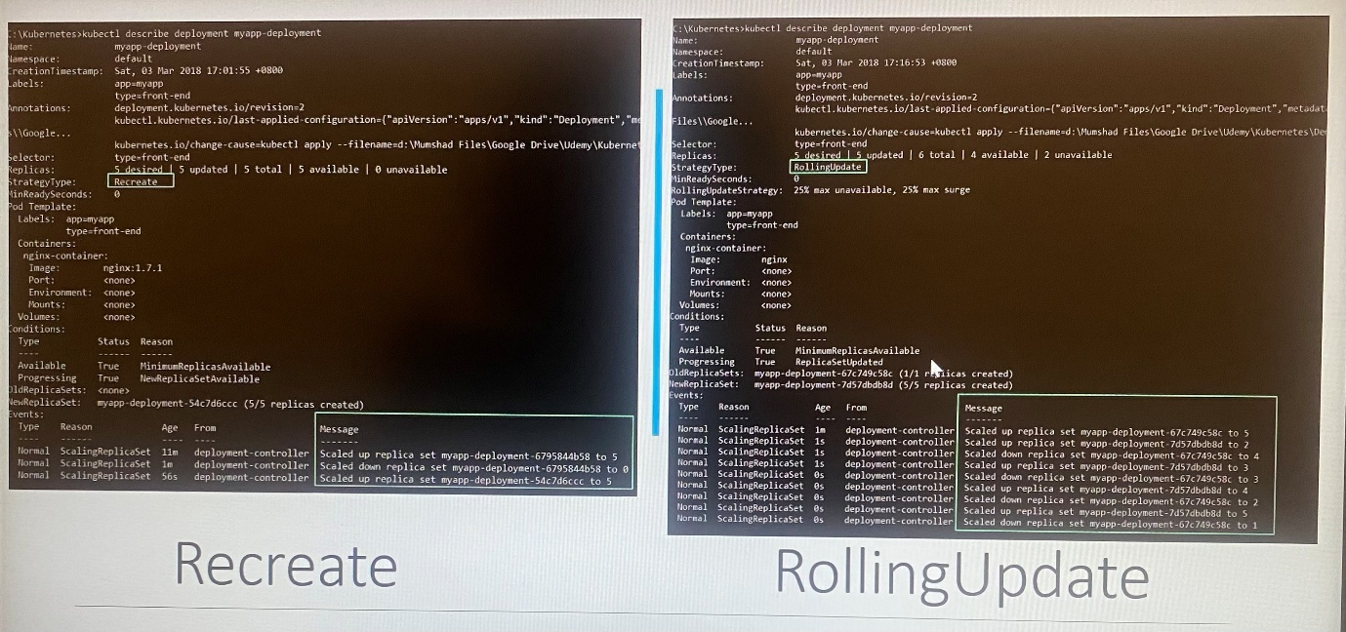)

*Upgrades*

- It creates new ReplicaSet automatically and create the number of pods one at a time to meet the desired number of replicas

-When you upgrade the application, Kubernetes deployment create new replica set and starts creating pods. At the same time, taking down pods in old ReplicaSet. This behavior will indicate by checking the event section in command *kubectl get replicaset*

*Rollback*

- When you need to rollback to previous deployment revision after latest upgrade is complete. Then the deployment will destroy the pods in new ReplicaSet and brings the older one up with the old ReplicaSet. Note that old replicaset will remain on the system in case it need rollback the deployment in future.

kubectl rollout undo deployment <name of deployment >

Alternatively, you can rollback to a specific revision by specifying it with --to-revision:

kubectl rollout undo deployment/nginx-deployment --to-revision=2

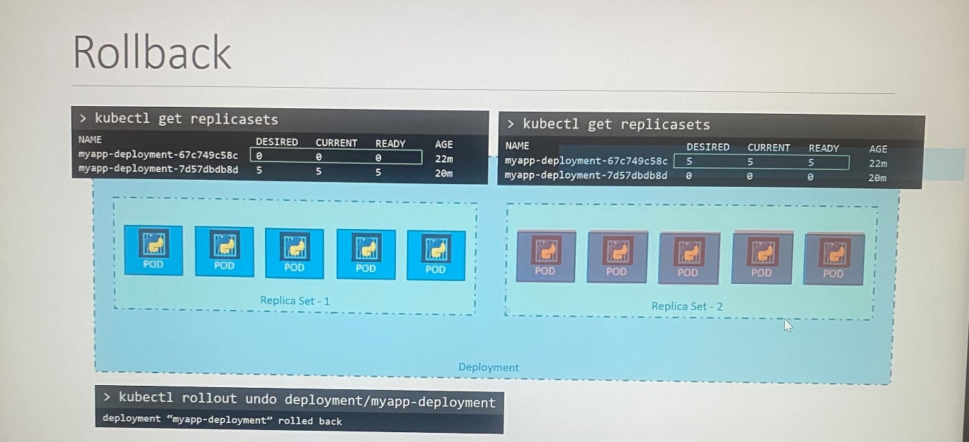

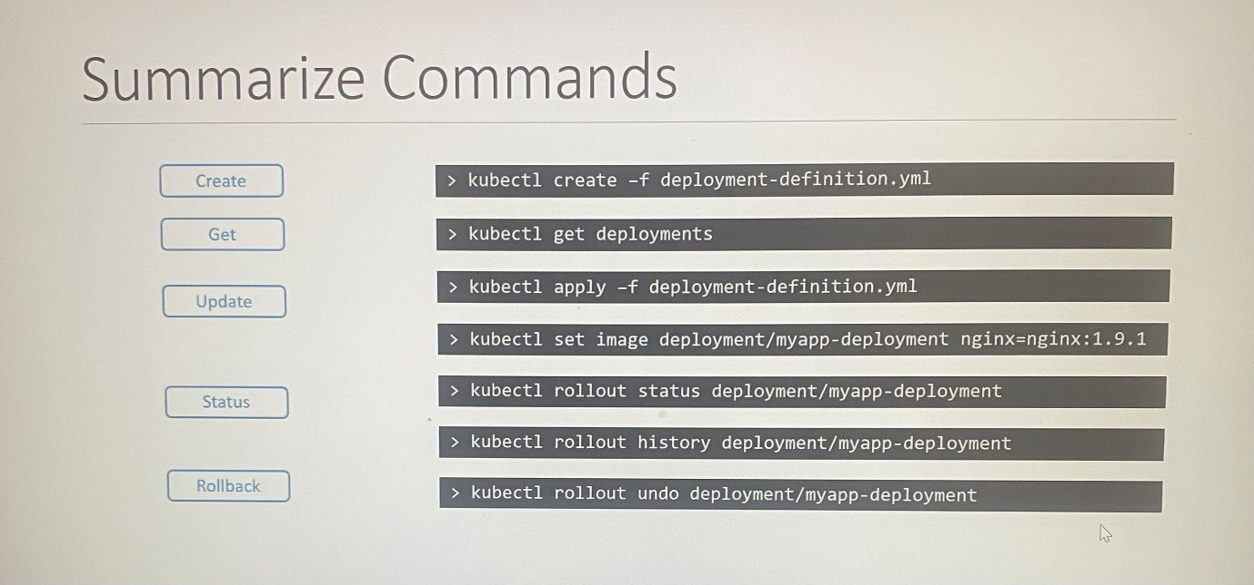

Use k alias for kubectl in the command line.

**Configure Applications**

Configuring applications comprises of understanding the following concepts.

- Configuring command and arguments on applications

- Configuring Environmental Variables

- Configuring Secrets

**Commands**

\*\* What if you run a docker container from an Ubuntu image, when you run ***docker run ubuntu ,*** it runs an instance of ubuntu image and exits immediately. The container lists as exited state. Unlike virtual machine, containers are not meant to host an operating system. Containers are meant to run specific service and application( task or process) such as instance of web server, application server, database or to carry some kind of computation or analysis task. Once the task is complete, the container exits. A container only lives as long as the process is alive.

If you look Dockerfile of Ubuntu image, it uses bash as default command. The bash is not a process like a web server or database server. It is a shell that listens inputs from terminal. If it cannot find the terminal, it exits. Docker doesn't by default attach the terminal to a container when it is run.

Ubuntu is an image of an OS that is used as the base image for other applications. There is no process or application running in it by default.

In this case, you can instruct to run a process with docker run command, it overrides the default command specified within the image. For example, a sleep command with a duration. When container starts , it runs to sleep command and goes into sleep after the duration completes. When the sleep command stops running, then container exits.

An option is to append command to docker run command which overrides the command specified within the image.

docker run ubuntu [COMMAND]

docker run ubuntu sleep 5 ; the appended command will run 5 seconds and exits

If you need to run the sleep command always when the container starts, specify the sleep command in the image.

FROM Ubuntu

CMD sleep 5

CMD command param1 CMD sleep 5 ; shell form

CMD["command","param1"] CMD ["sleep","5"] ; JSON array format where first element of the array should be executable. Do not specify command and parameter like this. CMD ["sleep 5"]

docker run ubuntu 10 ; If you specify ENTRYPOINT instruction within the Dockerfile, parameter append to the command in ENTRYPOINT will be invoked by the number of seconds that container should sleep which is specified in docker run command

\*ENTRYPOINT is the command to run at startup.

\*CMD is the default parameter pass to the command.

Thus, command defines with docker run take precedence over within the instruction in Dockerfile whereas in the case of ENTRYPOINT, command line parameter will be appended.

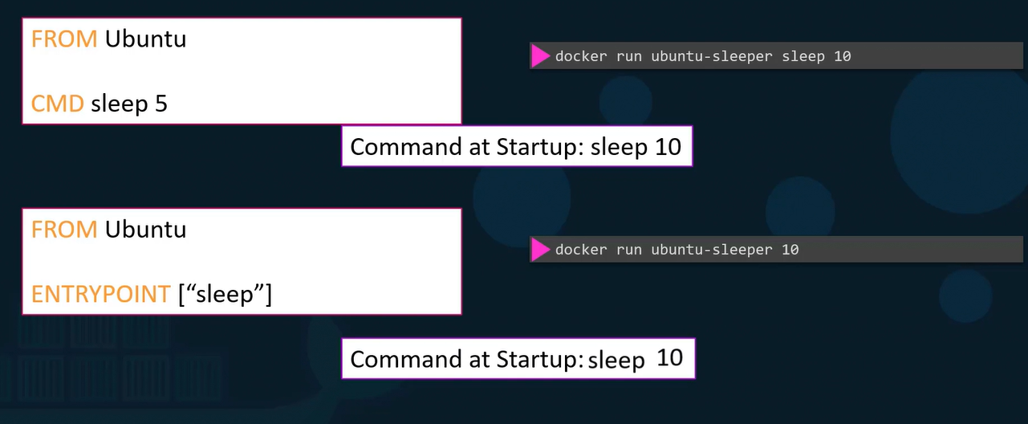

If you run docker run ubuntu-sleeper without command line parameter, it shows error as missing operand because it only runs sleep command without an operand at startup.

To set default vale as operand when you don't specify parameter in command line, we use ENTRYPOINT and CMD together in Dockerfile where CMD instruction will be appended to ENTRYPOINT instruction.

If you specify command line parameter in docker run command, it overrides the CMD and ENTRYPOINT instruction in Dockerfile. In order to happen this, you should specify command and ENTRYPOINT in JSON array format.

If you specify ENTRYPOINT parameter in command line, it overrides the instruction specified in Dockerfile

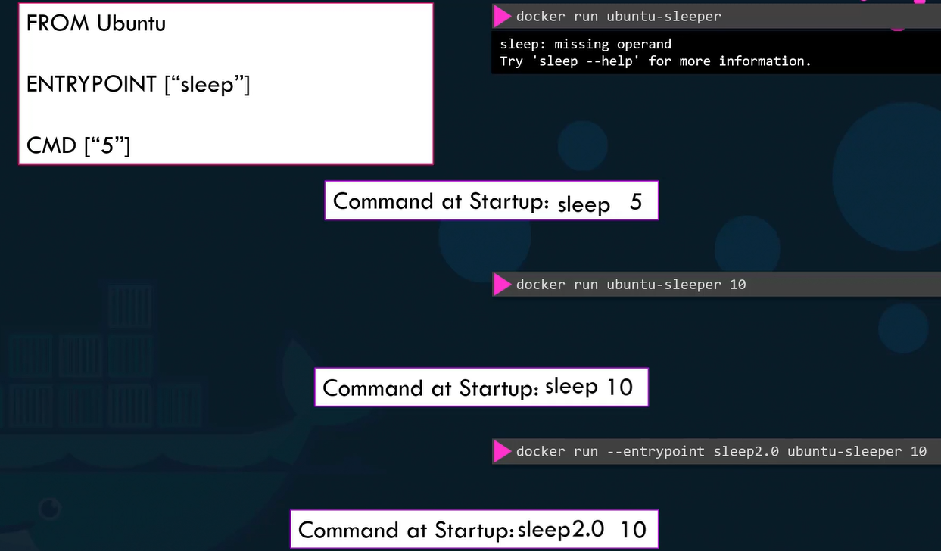

Bash script - To send multiple requests to test the web application

for i in {1.35}; do

kubectl exec --namespace=kube-public curl -- sh -c 'test=`wget -qO- -T 2 <http://webapp-service.default.svc.cluster.local:8080/info> 2>&1` && echo "$test OK" || echo "Failed"';

echo ""

done

**Commands and Arguments**

docker run - -name ubuntu-sleeper ubuntu-sleeper 10

Anything append to docker run command will go to args property of the pod definition file

-With the args option of pod definition file, it overrides CMD instruction in Dockerfile

-With command option in pod definition file, it overrides ENTRYPOINT instruction in the Dockerfile.

All the element under the command must be string.

apiVersion: v1

kind: Pod

metadata:

name: ubuntu-sleeper-pod

spec:

containers:

- name: ubuntu-sleeper

image: ubuntu-sleeper

command: [“sleep2.0”]

args: [“10”]

OR

command:

- “sleep”

- “1200”

OR

command: ["sleep2.0" , "10" ]

kubectl run --restart=Never --image=busybox static-busybox --dry-run=client -o yaml --command -- sleep 1000 > /etc/kubernetes/manifests/static-busybox.yaml

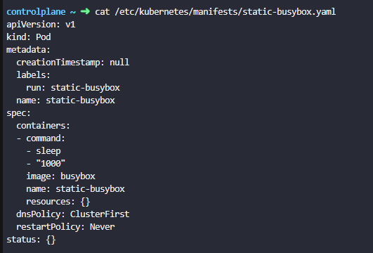

kubectl run <pod name> - -image=<image name> -- --color green ; If the docker image is built and pod is running with the image, only specify the arguments using kubectl where left side of -- are options for kubectl utility and right side of -- are options for container.

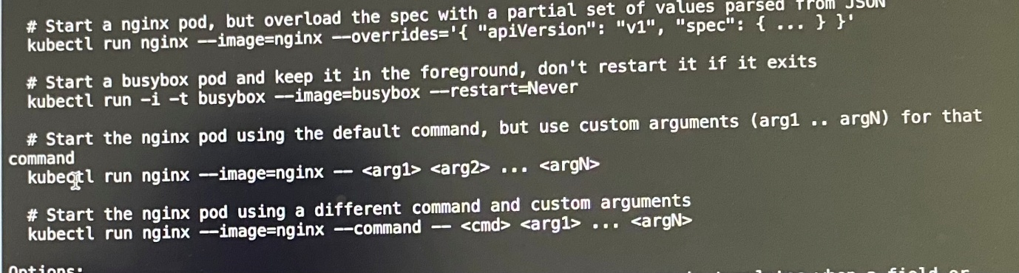

**Environment variables**

- Use **env** property to set environment variable in pod definition file

- Env is an **array** where every items consist **name** and **value** property as key and value pair. **name** is name of environment variable and **value** is its value

*ENV value types*

1. Plain key value

env:

- name: APP\_COLOR

value: pink

- name: APP\_MODE

value: prod

Example:

spec:

containers:

- env:

- name: APP\_COLOR

value: pink

image: kodekloud/webapp-color

imagePullPolicy: Always

name: webapp-color

resources: {}

2. ConfigMap

env:

- name: APP\_COLOR

valueFrom:

configMapKeyRef:

name: <ConfigMap\_Name>

key: <Key\_Name>

3. Secret

env:

- name: APP\_COLOR

valueFrom:

secretKeyRef:

------------------------------------

NODE\_NAME is sourced from fieldRef: spec.nodeName, which injects the actual node name into the container’s environment at runtime.

env:

- name: NODE\_NAME

valueFrom:

fieldRef:

fieldPath: spec.nodeName

------------------------------------------------

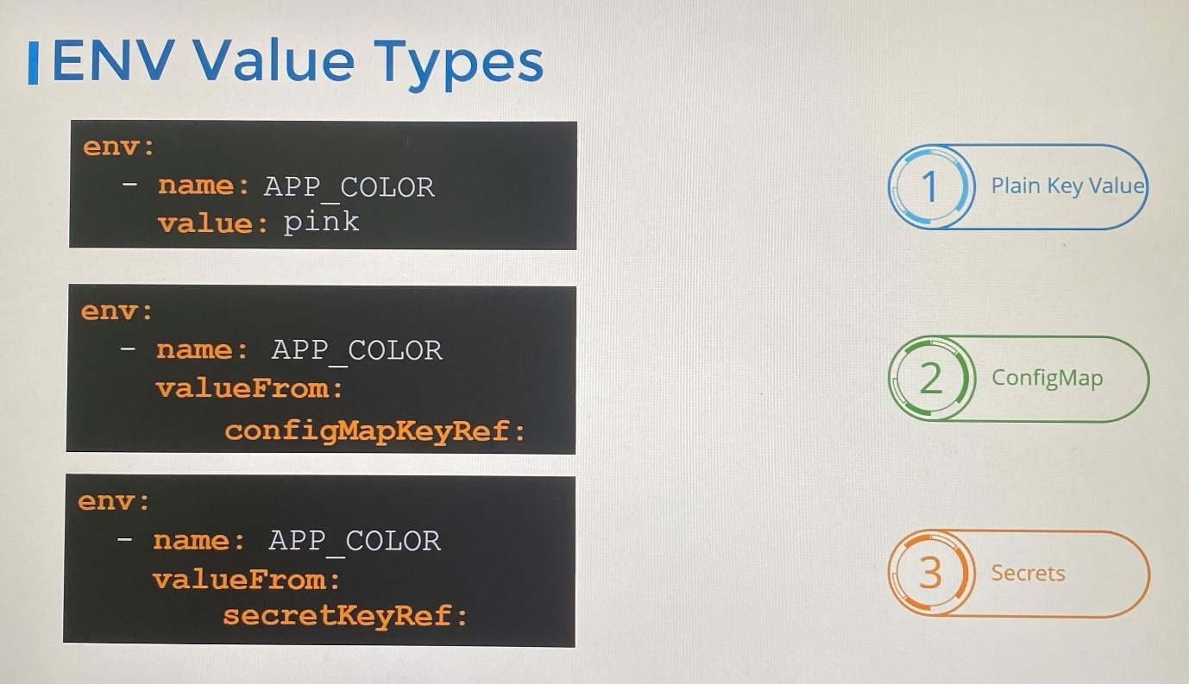

**ConfigMaps**

-A ConfigMap is an API object used to store non-confidential data in key-value pairs. Pods can consume ConfigMaps for environment variables, command-line arguments, or configure them as configuration files in a volume.

- If you adjust any change on image or whatever on your app, you have to rebuild it and deploy with whole process using pod definition file. When you have lot of pod definition files, it is difficult to manage environment variables stored with query’s file, ConfigMap helps to take this information out of pod definition file and also to centrally manage.

- ConfigMaps are used to pass configuration data in the form of key value pair in Kubernetes and inject environment variable for application hosted inside the container in the pod

- It contains configuration data such as URL of database, database credentials, some other services

- ConfigMaps store data in plaintext format

- Two phases involved in configuring config maps: Create ConfigMaps and Inject ConfigMaps

***Creating ConfigMaps***

Imperative approach : kubectl create configmap

Option 1: kubectl create configmap <configmap name> - -from-literal=<key>=<value>

kubectl create configmap app-config - -from-literal=APP\_COLOR=blue ; you can specify multiple key value pair with multiple - -from-literal

kubectl create configmap app-config --from-literal=APP\_COLOR=blue \

--from-literal=APP\_MOD=prod

Option 2: kubectl create configmap <configmap name> - -from-file=<path-to-file> -n kube-system

kubectl create configmap <configmap name> - -from-file=/root/my-schedule-config.yaml -n kube-system

Declarative approach: kubectl create -f

apiVersion: v1

kind: ConfigMap

metadata:

name: app-config

data:

APP\_COLOR: blue

APP\_MODE: prod

Kubectl get configmaps | cm ; to view configmaps

kubectl describe configmaps; list configuration data o data section

***Inject ConfigMaps to pod***

- Add new property to the container list called **envFrom**

- envFrom is a list where we can pass many environment variable as we required with **configMapRef** property

-Each item of the list corresponds to a configmap item

-envFrom is a parameter that is part of containers list in the pod

Option 1: using envFrom property

spec:

containers:

- name: simple-web app-color

image: simple-web app-color

envFrom:

- configMapRef:

name: app-config ; map the ConfigMap created where app-config is the name of configmap

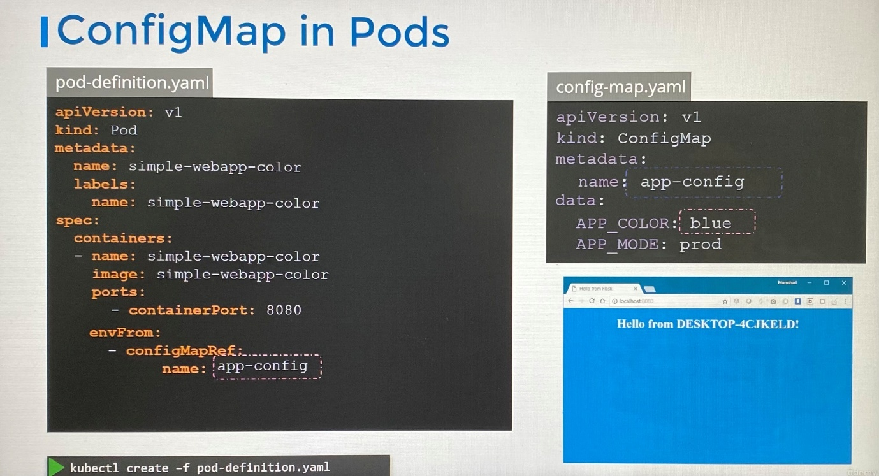

Option 2: using Single ENV

env:

- name: APP\_COLOR

valueFrom:

configMapKeyRef:

name: app-config

key: APP\_COLOR

Example:

---

apiVersion: v1

kind: Pod

metadata:

labels:

name: webapp-color

name: webapp-color

namespace: default

spec:

containers:

- env:

- name: APP\_COLOR

valueFrom:

configMapKeyRef:

name: webapp-config-map

key: APP\_COLOR

image: kodekloud/webapp-color

name: webapp-color

Option3 : using ConfigMap as volume

volumes:

- name: app-config-volume

configMap:

name: app-config

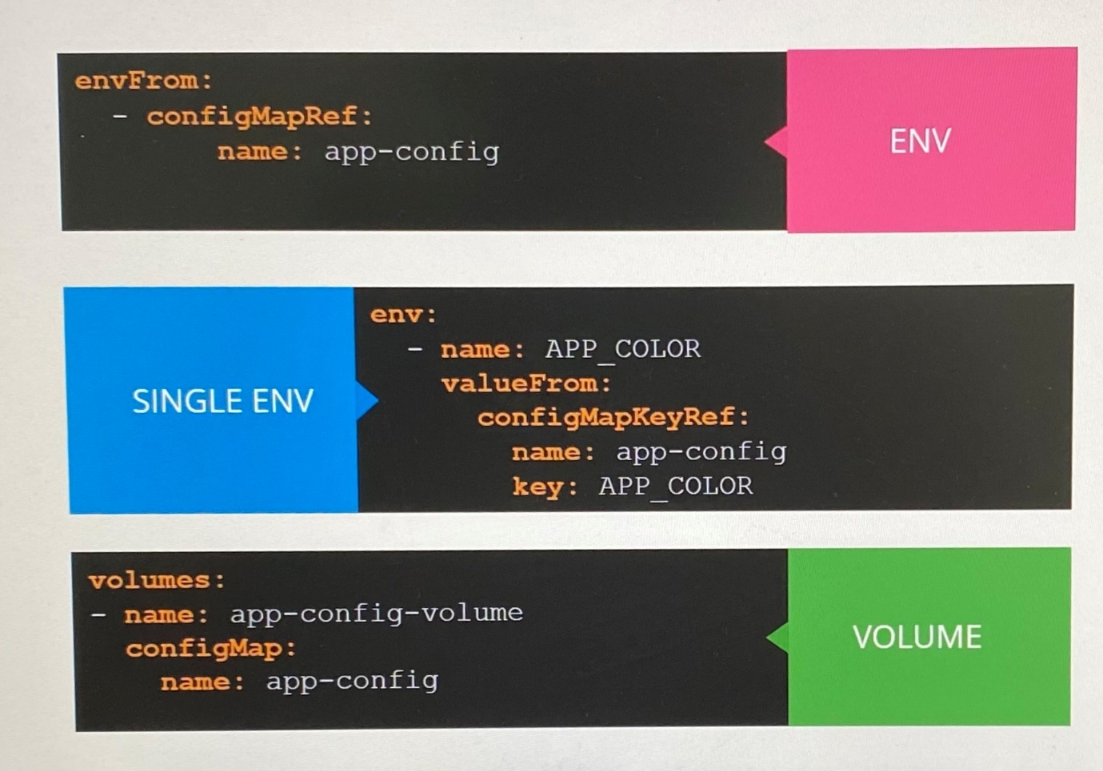

----------------------------------

You have probably never used this useful Configmap option👇

In Kubernetes,

When you reference a ConfigMap in your Pod spec, it must exist before the Pod starts.

You can't deploy your application if the ConfigMap is missing.

For example,

If your Pod references "common-config" ConfigMap, Kubernetes will crash the Pod with ImagePullBackOff or similar errors if that ConfigMap doesn't exist.

However, when you set optional: true in your pod spec,

Pod starts even if ConfigMap doesn't exist. You can also use this option in the volume section.

A simple real world use case for this is,

When you want to deploy your application with default settings first, and later apply environment-specific configurations without needing to restart the pods.

𝗡𝗼𝘁𝗲: When using optional Configmap, your application should still handle missing Configmap data gracefully.

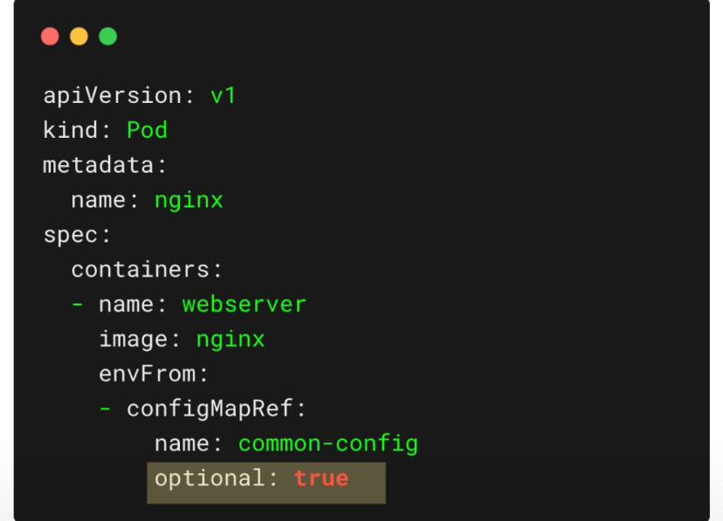

--------------------------------------

**Secrets**

- Don’t put credentials into ConfigMap as they are frequently change and it store data in plaintext.

- Secret uses to store sensitive information such as password, keys in base64 encoded format

- The built-in security mechanism is not enabled by default.

-Two steps involve in working with secret: Create the secret and Inject secret to the pod

***Create secrets***

*Imperative approach*

Option1:

kubectl create secret generic <secret-name> - -from-literal=<key>=<value>

Example:

kubectl create secret generic app-secret --from-literal=DB\_Host=mysql --from-literal=DB\_User=root --from-literal=DB\_Password=passwrd ; specify from-literal option multiple time if you need to add additional key value pair

Option2:

kubectl create secret generic <secret-name> - -from-file=<path-to-file> ; when you have multiple secrets to specify

*Declarative approach*

kubectl create -f

apiVersion: v1

kind: Secret

metadata:

name: app-secret

data:

DB\_Host: <encoded password >

DB\_User: <encoded password >

----------------------

*Encode secret*

On a Linux host, run the command to encode the password,

echo -n ‘password’ | base64

kubectl get secrets ; shows name, type, number of data in secret and age

kubectl describe secrets <secret name> ; shows attributes in the secret but hide the values in it

kubectl get secret app-secret -o yaml ; to see the values with encoded format

*Decode secret*

On a Linux host, run the command to encode the password,

echo -n ‘encoded password’ | base64 - -decode

echo "encoded password" | base64 - -decode

***Inject secrets to pod***

Option 1: using envFrom property

spec:

containers:

- name: simple-web app-color

image: simple-web app-color

port:

- containerPort: 8080

envFrom:

- secretRef:

name: app-secret ; map the name of secret created to get all secrets

Option 2: using Single ENV

env:

- name: DB\_Password

valueFrom:

secretKeyRef:

name: app-secret

key: DB\_Password ; to get single environment variable from secret file

Option 3: Secret as Volume

volumes:

- name: app-secret-volume

secret:

secretName: app-secret

Create TLS secret webhook-server-tls for secure webhook communication in webhook-demo namespace. We have already created below cert and key for webhook server which should be used to create secret.

Certificate : /root/keys/webhook-server-tls.crt

Key : /root/keys/webhook-server-tls.key

kubectl -n webhook-demo create secret tls webhook-server-tls \

--cert "/root/keys/webhook-server-tls.crt" \

--key "/root/keys/webhook-server-tls.key"

-If there are n number of attributes in secret file, n number of files are created

- Secrets are not encrypted.Only encoded

- Do not check-in secrets objects to Source Control Management along with code in source code repositories

- Secrets are not encrypted in ETCD. None of the data in ETCD is encrypted.

- Enable encryption at rest using ***EncryptionConfiguration*** object - <https://kubernetes.io/docs/tasks/administer-cluster/encrypt-data/>

**apiVersion**: apiserver.config.k8s.io/v1  
**kind**: EncryptionConfiguration  
**resources**:  
 - **resources**:  
 - secrets  
 - configmaps  
 - pandas.awesome.bears.example  
 **providers**:  
 - **aescbc**:  
 **keys**:  
 - **name**: key1  
 *# See the following text for more details about the secret value*  
 **secret**: <BASE 64 ENCODED SECRET>  
 - **identity**: {} *# this fallback allows reading unencrypted secrets;*  
 *# for example, during initial migration*

- Anyone able to create pods/deployments in the same namespace can access the secrets

- Configure least-privileges access to Secrets-RBAC

- Consider third party secrets store providers, AWS provider, Azure provider, GCP provider, Vault provider

Data in ConfigMap and Secret in the pod can use as environment variables or as a properties file

Also the way kubernetes handles secrets. Such as:

* + A secret is only sent to a node if a pod on that node requires it.
  + Kubelet stores the secret into a tmpfs so that the secret is not written to disk storage.
  + Once the Pod that depends on the secret is deleted, kubelet will delete its local copy of the secret data as well.

Read about the [protections](https://kubernetes.io/docs/concepts/configuration/secret/#protections)and [risks](https://kubernetes.io/docs/concepts/configuration/secret/#risks) of using secrets [here](https://kubernetes.io/docs/concepts/configuration/secret/#risks)

There are other better ways of handling sensitive data like passwords in Kubernetes, such as using tools like Helm Secrets, HashiCorp Vault, AWS Secrets Manager, Google Secrets Manager and Azure Key Vault

**Secret Store CSI Driver**

* + Secrets Store CSI Driver synchronizes secrets from secrets external APIs and mounts them into containers as volumes
  + Allows you to manage secrets in a central place like Hashicorp Vault or AWS Secrets Manager
  + Don't need to check secrets into Git

Dive deep into the world of Kubernetes security with our comprehensive guide to Secret Store CSI Driver.

<https://www.youtube.com/watch?v=MTnQW9MxnRI>

x`

**Encrypting secret data at rest**

We focus on how data is stored in ETCD server. etcdctl command passing the CA certificates for authentication.

>etcdctl ; check etcdctl command line

>apt-get install etcd-client ; install etcd client utility in the system

ETCDCTL\_API=3 etcdctl **\** --cacert=/etc/kubernetes/pki/etcd/ca.crt **\** --cert=/etc/kubernetes/pki/etcd/server.crt **\** --key=/etc/kubernetes/pki/etcd/server.key **\** get /registry/secrets/default/secret1 | hexdump -C ; replace secret1 with your secret to see the unencrypted format of secret. This command to see the value of secret

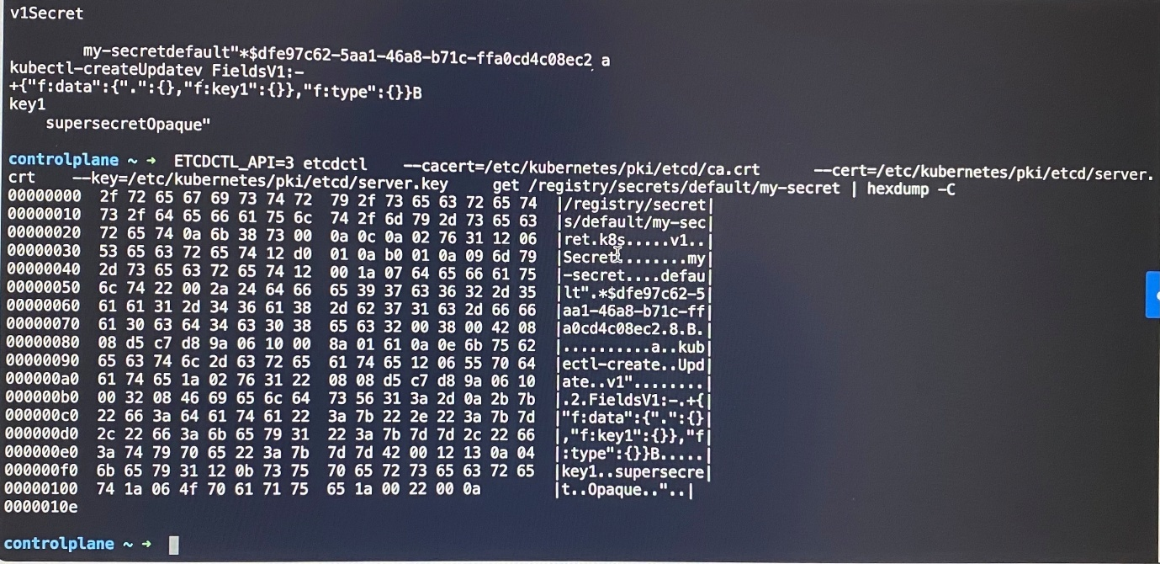

[Encrypting Confidential Data at Rest | Kubernetes](https://kubernetes.io/docs/tasks/administer-cluster/encrypt-data/)

The secret data is stored in ETCD as unencrypted format.

The kube-apiserver process accepts an argument - -***encryption-provider-config*** the controls how API data is encrypted in etcd.

ps -aux | grep kube-api ; check kube-apiserver runs as process

ps -aux | grep kube-api | grep “encryption-provider-config” ; to check encryption at rest is already enabled. If it doesn't return a result which means encryption is not enabled.

Otherwise, checks the option - -***encryption-provider-config*** in kubeapi-server manifest file stores in /etc/kubernetes/manifests path

-In **EncryptionConfiguration** object you can specify the **resources** that need to be encrypted at rest such as secrets , **providers** that specify encryption algorithm with custom keys such as secretbox, AES-GCM, AES-CBC. With the providers, you can specify the keys that should use for encryption. The providers and keys are list/array. The provider on top of the list takes to encrypt the resources specified.

\*identity provider doesn't provide encryption by default

**apiVersion**: apiserver.config.k8s.io/v1  
**kind**: EncryptionConfiguration  
**resources**:  
 - **resources**:  
 - secrets  
 **providers**:  
 - **aescbc**:  
 **keys**:  
 - **name**: key1  
 **secret**: <BASE 64 ENCODED SECRET>  
 - **identity**: {} *# REMOVE THIS LINE*

head -c 32 /dev/urandom | base64 ; generate 32 byte base64 encoded secret key for EncryptionConfiguration

- You can specify EncryptionConfiguration in kubeapi server manifest file that stored in /etc/Kubernetes/manifest using an argument encryption-provider-config and map file to volume and volume mount.

apiVersion: v1

kind: Pod

metadata:

annotations:

kubeadm.kubernetes.io/kube-apiserver.advertise-address.endpoint: 10.20.30.40:443

creationTimestamp: null

labels:

app.kubernetes.io/component: kube-apiserver

tier: control-plane

name: kube-apiserver

namespace: kube-system

spec:

containers:

- command:

- kube-apiserver

...

- --encryption-provider-config=/etc/kubernetes/enc/enc.yaml # add this line

volumeMounts:

...

- name: enc # add this line

mountPath: /etc/kubernetes/enc # map the volume to directory path in container

readOnly: true # add this line

...

volumes:

...

- name: enc # add this line

hostPath: # add this line

path: /etc/kubernetes/enc # directory in node that has the EncryptionConfiguration object

type: DirectoryOrCreate # add this line

- Then any secret after enabling encryption at rest will be encrypted but not the secret before enabling. Once make any change or update on secret previously created, encryption at rest is reapplied to that secret.

kubectl get secrets - -all-namespace -o json | kubectl replace -f - ; update existing secrets with same data by applying encryption using EncryptionConfiguration object

![controlplane ~ > kubectl get secrets -- all-namespaces -o json | kubectl replace -f - 
secret/my-secret replaced 
secret/my-secret-2 replaced 
secret/bootstrap-token-gsdot4 replaced 
controlplane ~ ~ > ETCDCTL_API=3 etcdctl 
-- cacert=/etc/kubernetes/pki/etcd/ca.crt 
-- cert=/etc/kubernetes/pki/etcd/server. 
crt 
-- key=/etc/kubernetes/pki/etcd/server.key 
00000000 
2f 72 65 67 69 73 74 72 
79 2f 73 65 63 72 65 74 
get /registry/secrets/default/my-secret | hexdump -C 
//registry/secret | 
00000010 
73 2f 64 65 66 61 75 6c 
74 2f 6d 79 2d 73 65 63 
s/default/my-sec | 
00000020 
72 65 74 0a 6b 38 73 3a 
65 6e 63 3a 61 65 73 63 
| ret. k8s : enc: aesc| 
00000030 
62 63 3a 76 31 3a 6b 65 
79 31 3a 09 
50 df 57 0f 
bc: v1: key1: . P.W. 
00000040 
f1 0e c6 bb a8 0f e3 b8 
b3 
75 3a d2 
e5 
ad 42 0c 
00000050 
28 8f Ød 1a 02 27 57 80 
..........:... B. 
db 
e6 9a fo 
Ød 92 92 94 
( .... 'W ... 
... 
00000060 
71 bc 43 b4 
ce 
7a 6d c3 
83 
70 73 e3 
ec 9c 70 9b 
q. C. . zm. . ps . . . p. 
00000070 
c6 0c 27 dd 
20 c4 
43 
76 
6f 
03 4f 
11 
a1 
87 34 0a 
.. '. . Cvo.O ... 4. 
00000080 
0a 06 9d 99 44 18 
a1 fc 
72 Of ec 15 
bb a7 df 65 
.... D ... r ...... e 
00000090 
c4 3d 9b 54 ec 3a bb 9e 
94 fb 61 8a d5 a4 d2 da 
.=. T .:.... a ..... 
000000a0 
06 0a 9a d7 31 13 d4 
3b 
2d 6e 27 
ee 
40 38 69 b3 
.... 1 ..;- n' . @8i. 
000000b0 
a0 7f 
36 33 
91 52 
сб 
63 
9b 
e1 64 b5 ec d3 67 39 
. . 63.R. c. . d. . . g9 
000000c0 
35 84 d4 da 
05 48 
d7 
99 
7d 34 36 5e 98 93 
77 ec 
|5 .... H .. }46^. . w. | 
000000d0 
1b db 72 97 4b 94 6e 0c 
68 dd c2 
d0 9c a7 43 b5 
| .. r.K.n.h ..... C. | 
000000e0 
57 9e 51 5e cd bf 
12 e9 
12 78 d2 
fd b9 b7 
a9 4d 
|W.Q^ ..... x ..... M| 
000000fØ 
1f fø af 26 94 b7 
16 b5 
d5 19 
55 82 42 c5 f3 6f 
... &. ..... U.B. . o 
00000100 
28 7c 56 1e 85 d9 12 a2 
85 fe d3 56 5c f5 fa 19 
(|V ........ V\ ... | 
00000110 
e1 a6 4b e0 d1 3e fc 
1f 
d9 91 08 f8 c0 0e e2 42 
.. K .. > ........ B 
00000120 
15 32 a3 7d 33 62 ea 7c 
5e a6 dd a8 51 38 fa 25 
.2.}3b. | ... 08.% | 
00000130 
23 c0 a2 0a 
0000013c 
25 aa c4 9c 34 97 d5 3f 
% ... 4. . ? #. . . | 
controlplane ~ > ](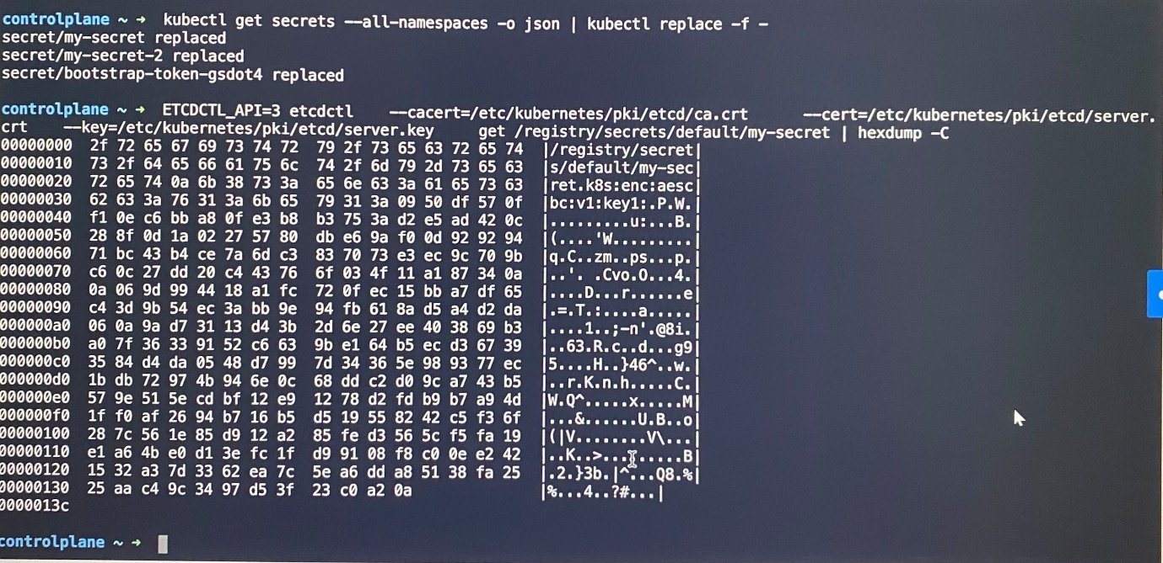)

**Multi Container Pods**

The idea of decoupling a large monolithic application into sub components known as microservices enables to develop and deploy a set of independent, small, and reusable code. This architecture can then help to scale up, scale down, as well as modify each service as required, as opposed to modifying the entire application.

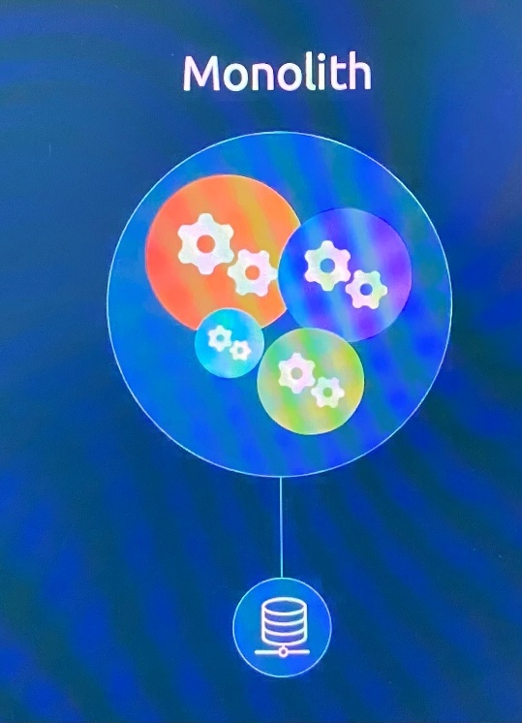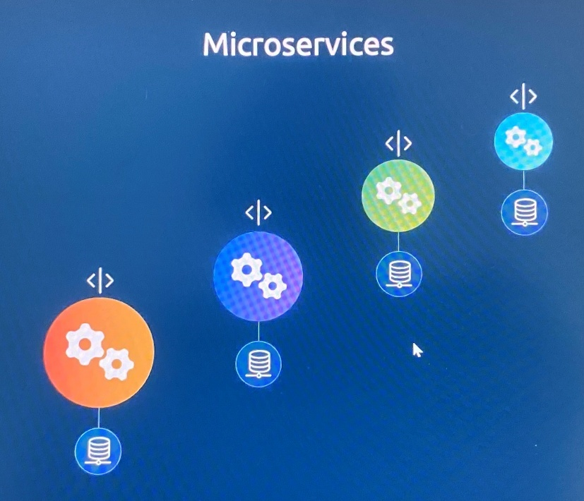

At times, you may need two services to work together, such as a web server and a logging service. You need one agent instance per web server instance paired together that can scale up and down together.

-Multi container pods that share the same pod life cycle(can create and destroy together), network space(refer to each other as localhost) and storage volumes(do not need volume sharing)

-Avoids volume sharing or services between the pods to enable communication between them

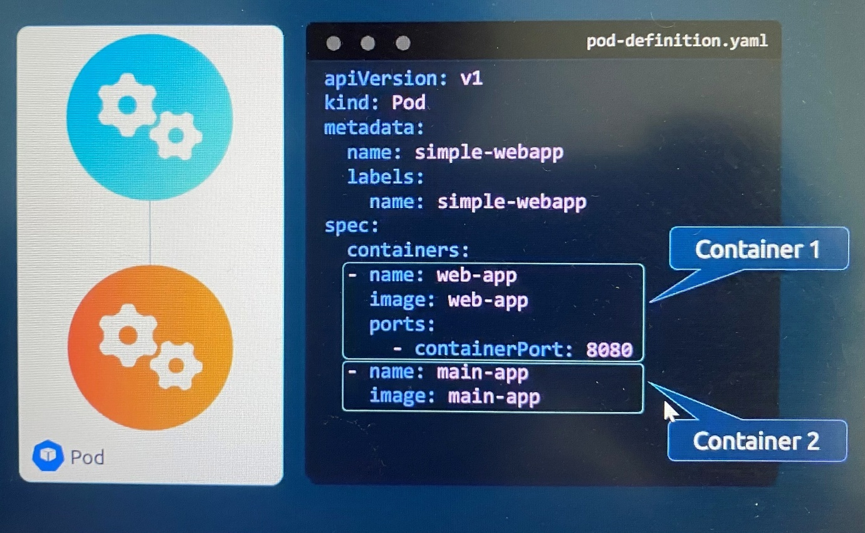

When log agent should run along with web server, create multiple container in same pod adding multiple container as array into pod definition file.

kubectl -n elastic-stack exec -it app -- cat /log/app.log ; inspect logs of container in interactive mode

\*\*\*Exam tips: If you need to create multi-container pod, first get create pod manifest file with single container with dry-run option. Then modify the pod manifest file by adding additional containers.

**Multi-container Pods Design Patterns**

There are 3 common patterns, when it comes to designing multi-container PODs.

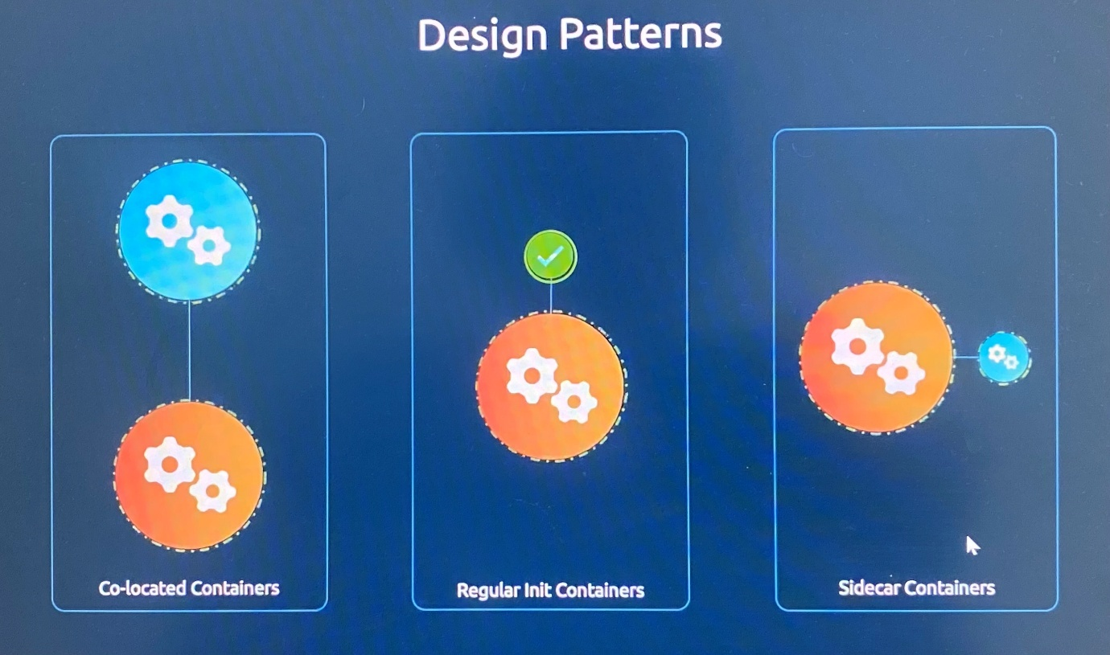

*Co-located Containers*

-This original form of multi-containers.

-Two containers running in a pod when two services are dependent on each other.

-Both containers run throughout entire pod lifecycle.

-Both containers start together and there is no guarantee which one would start before the other.

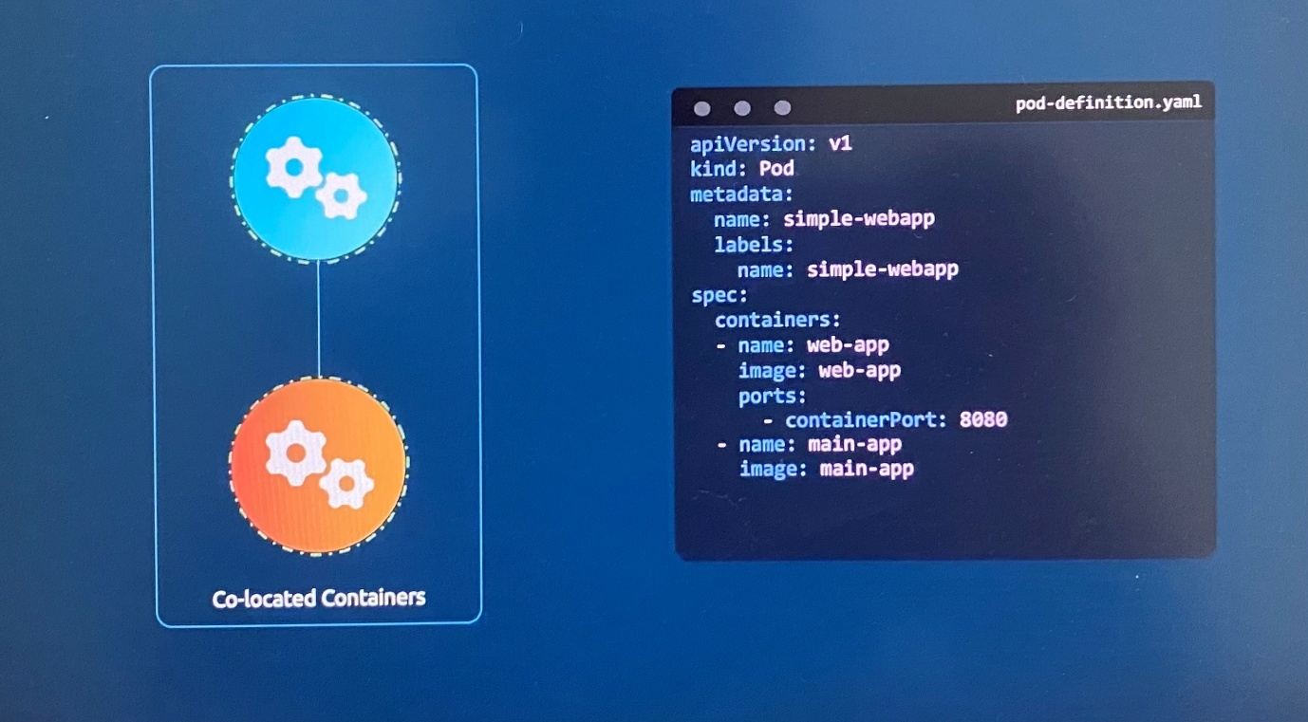

*Regular Init Containers*

-This is used when there are initialization steps to be performed when a pod starts before the main application itself. For example, this could be an init container that waits for a database to be ready before starting the main application.

-The init container does the job and ends its job, and then the main application starts.

-Instead of adding another container as second items in the container list, define separate property **intContainers** and add multiple init containers as list to be run sequentially.

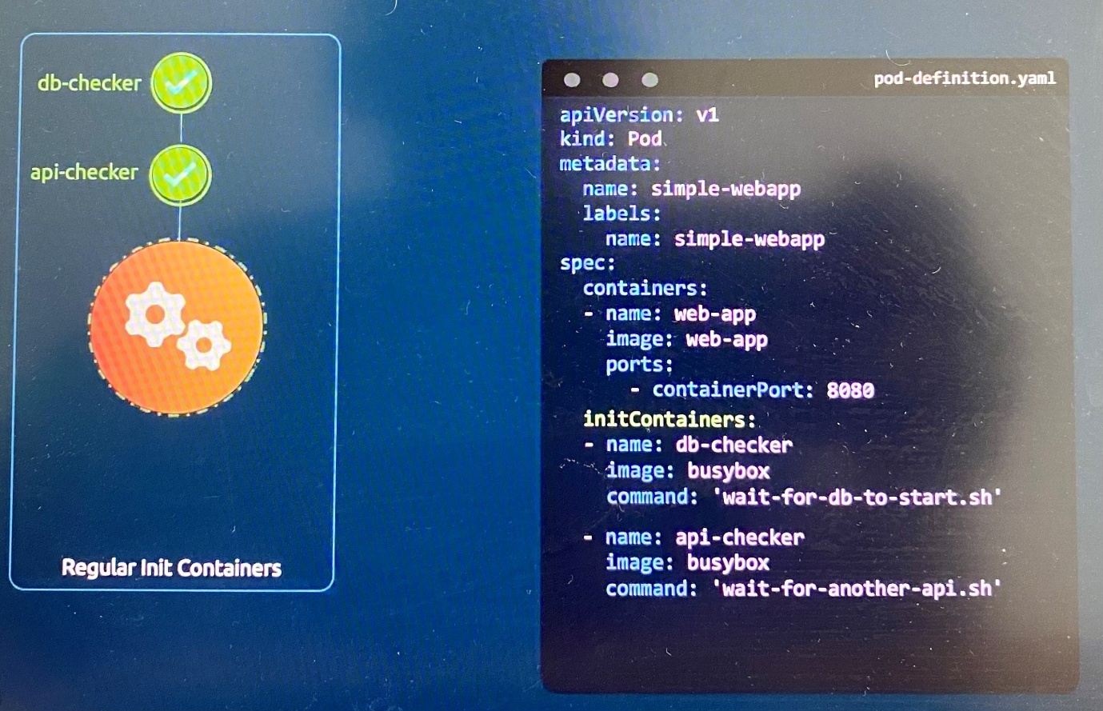

*Sidecar Containers*

- A sidecar container is set up like an init container where the sidecar starts first, does its job, but instead of ending its run, it continues to run throughout the life cycle of the pod as it has **restartPolicy** set to **always**.

-The main application starts after the sidecar container starts.

-This is useful when you have a log shipper of sorts that needs to be run, along with the main application that needs to start before the main app starts, but continue to run as long as the main app runs and then end after the main app ends.

-The main difference sidecar and co-located container is sidecar containers option provides the ability to specify an order of startup and then continue to run throughout the pod lifecycle.

[Sidecar Containers | Kubernetes](https://kubernetes.io/docs/concepts/workloads/pods/sidecar-containers/)

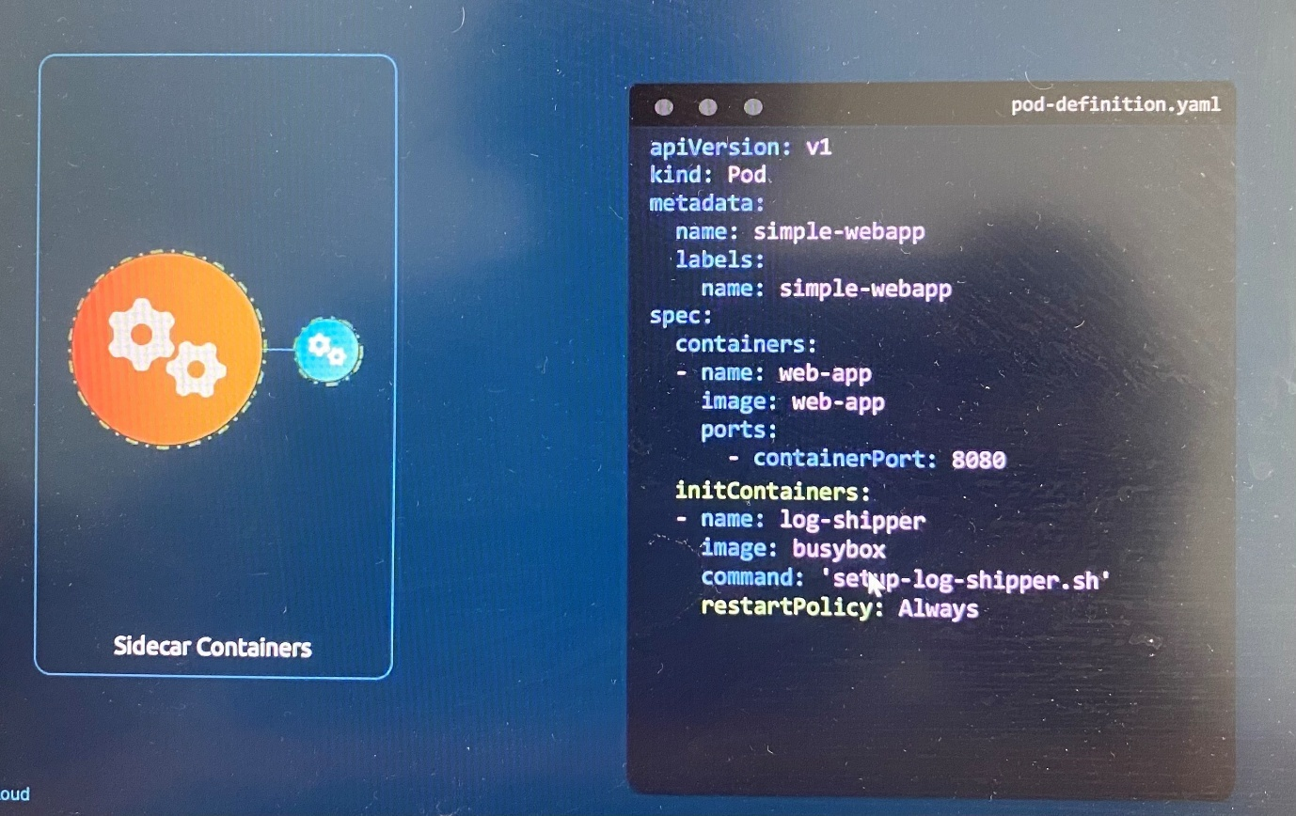

This is realistic example using the elastic search and Kibana stack.

**Elasticsearch** is itself is a component that captures the logs from different endpoints, different applications.

**Kibana** is a visualizer that visualizes the logs which is a dashboard that users or administrators look.

First we add a sidecar called Filebeat, which comes along with Elasticsearch. It starts before main application starts and end after main app ends so that it can capture any termination logs

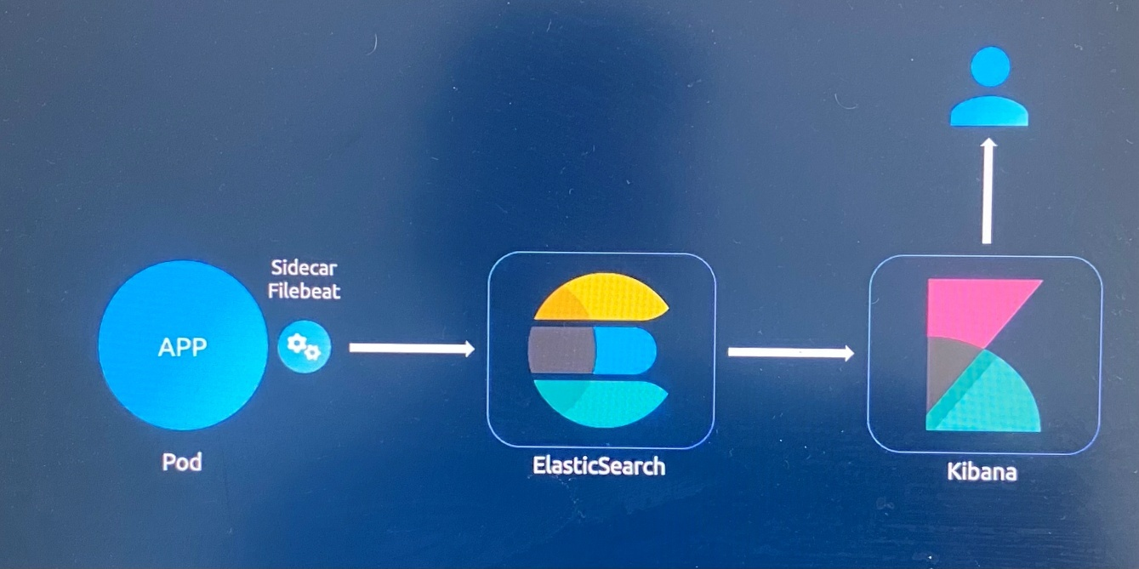

**InitContainers**

- In a multi-container pod, each container is expected to run process that stays alive as long as pod’s lifecycle

-For example in the multi-container pod that we talked about earlier that has a web application and logging agent, both the containers are expected to stay alive at all times. The process running in the log agent container is expected to stay alive as long as the web application is running. If any of them fails, the POD restarts.

- Use initContainer is for a process that pulls binary or code from a repository that will be used by main web application. That task will be run only one time when the pod is created or a process that waits for an external service or external database to be up or prepare startup script before actual application starts.

An initContainer is configured in a pod like all other containers, except that it is specified inside a initContainers section, like this:

apiVersion: v1

kind: Pod

metadata:

name: myapp-pod

labels:

app: myapp

spec:

containers:

- name: myapp-container

image: busybox:1.28

command: ['sh', '-c', 'echo The app is running! && sleep 3600']

initContainers:

- name: init-myservice

image: busybox

command: ['sh', '-c', 'git clone <some-repository-that-will-be-used-by-application> ; done;']

-When a POD is first created the initContainer is run, and the process in the initContainer must run to a completion before the real container hosting the application starts.

- You can configure multiple initContainers as well, like how we did for multi-containers pod. In that case each init container is run one at a time in sequential order

- If any of InitContainers fail to complete, Kubernetes restarts the pod repeatedly until the InitContainers succeeds

apiVersion: v1

kind: Pod

metadata:

name: myapp-pod

labels:

app: myapp

spec:

containers:

- name: myapp-container

image: busybox:1.28

command: ['sh', '-c', 'echo The app is running! && sleep 3600']

initContainers:

- name: init-myservice

image: busybox:1.28

command: ['sh', '-c', 'until nslookup myservice; do echo waiting for myservice; sleep 2; done;']

- name: init-mydb

image: busybox:1.28

command: ['sh', '-c', 'until nslookup mydb; do echo waiting for mydb; sleep 2; done;']

- Number of Init containers shows in Status as Init:0/2, if main container in the pod is not running state.

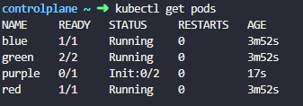

- Describe command specifies ***state*** and ***reason*** of init container. If the process is complete normally, the state should be ***Terminated*** and Reason should be ***Completed*** with ***Exit Code is 0***

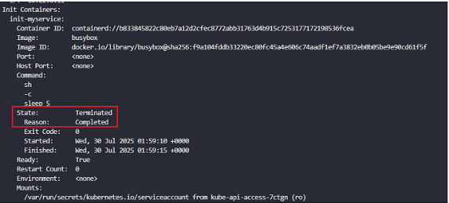

kubectl logs <pod name> -c <container name> ; check logs on specific container in the pod

\*\*Examtips: If you need to find pods that have Init Containers, check the describe command for all pods at one time. "kubectl describe pod"

**Self-Healing Applications**

Kubernetes supports self-healing applications through ReplicaSets and Replication Controllers. The replication controller helps in ensuring that a POD is re-created automatically when the application within the POD crashes. It helps in ensuring desired number of replicas of the application are running at all times.

Kubernetes provides additional support to check the health of applications running within PODs and take necessary actions through Liveness and Readiness Probes.

**Introduction to Autoscaling**

***Basics of scaling***

When load increases and run out of existing resources(CPU, memory) on the server that host application, we need to shut down the server and increase the size of the server vertically. That is referred as **vertical scaling**.

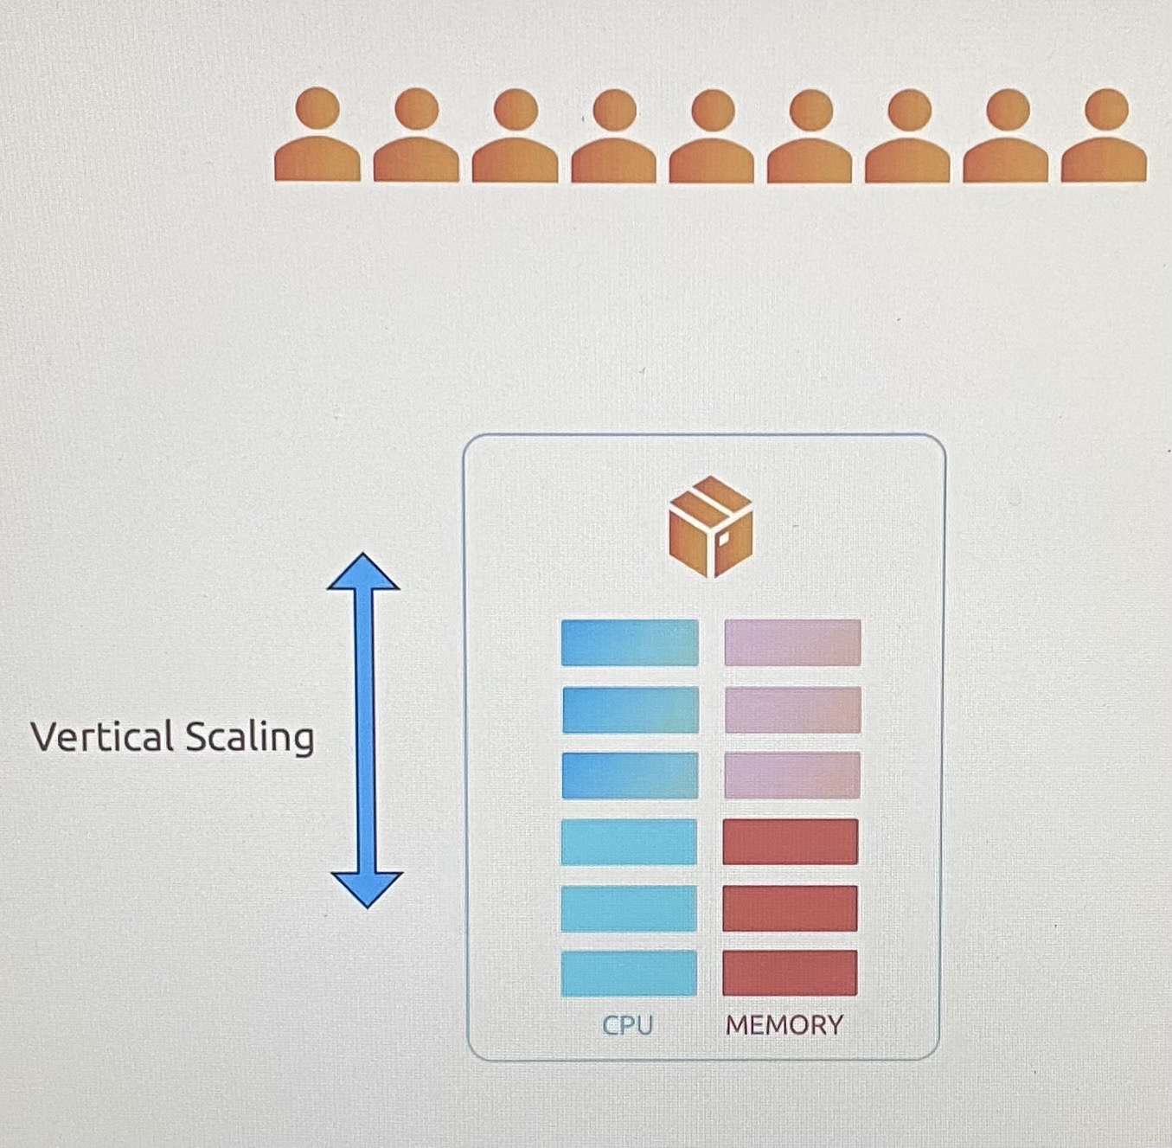

If the application support running in multiple instances, we can add more servers and share load between them instead shut down servers. This scaling is referred as **horizontal scaling**.

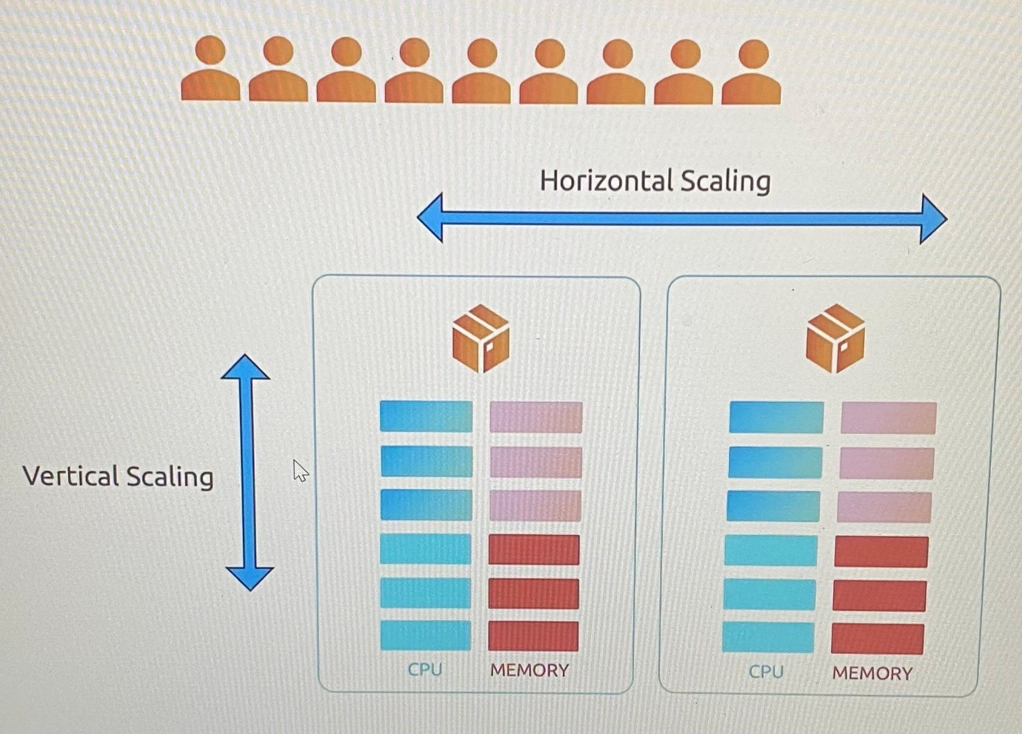

One of the major purposes of a container orchestrator like Kubernetes is to host applications in the form of containers and scale up and down based on demand.

There are two types of scaling in Kubernetes.

Scaling workloads - adding or removing containers or pods onto the cluster.

Scaling Cluster Infra - adding or removing more servers or infrastructure to cluster.

In scaling workloads,

horizontal scaling mean creating more pods

vertical scaling mean increasing the resources allocated to existing pods.

In Scaling Cluster Infra,

horizontal scaling mean creating more nodes to cluster

vertical scaling mean increasing the resources allocated to existing nodes.

There are two ways of scaling. There is the manual way and the automated way.

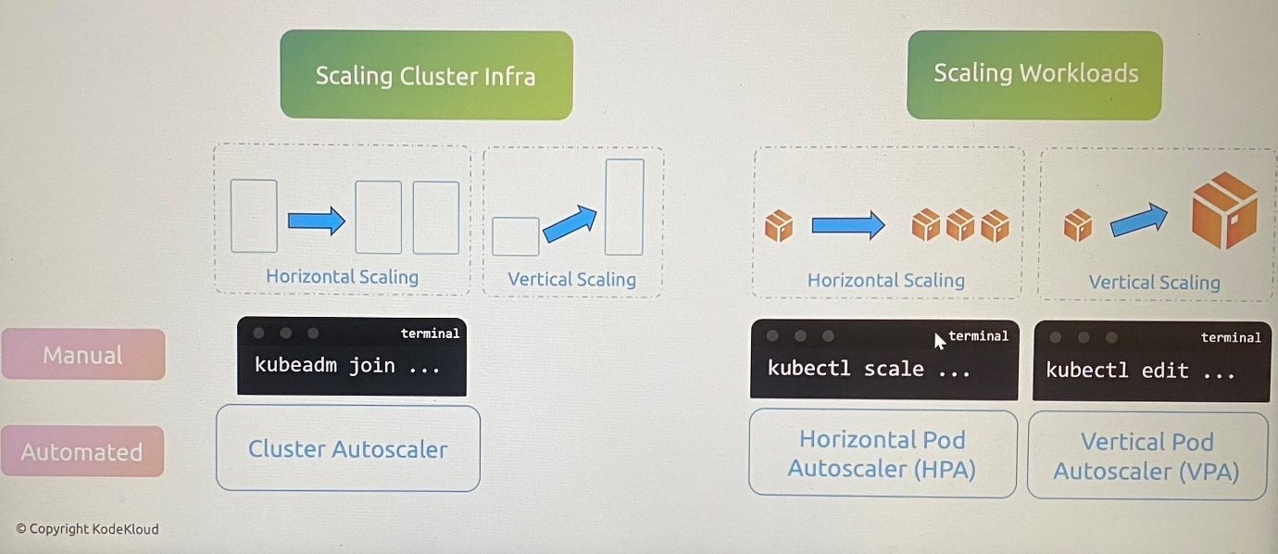

The manual approach of horizontal scaling cluster infra is to manually provision new nodes and then use the *kubeadm join* command to add the new nodes to the cluster.

The manual approach of vertical scaling cluster infra is not common approach because it will result in having to take down the server and applications running on them and then add more resources to the servers and bring it back up

The manual approach of horizontal scaling workloads is to run the ***kubectl scale*** command on the workload to scale up or down the number of pods.

The manual approach of vertical scaling workloads is to run the ***kubectl edit*** command to go in to that deployment or stateful set or replica set, and change the resource limits and requests associated with the pods.

The automated approach of horizontal scaling cluster infra is known as **Kubernetes Cluster Autoscaler**.

The automated approach of horizontal scaling cluster workloads is known as **Horizontal Pod Autoscaler(HPA)**.

The automated approach of vertical scaling cluster workloads is known as **Vertical Pod Autoscaler(VPA)**.

The ***kubectl scale*** command can be used to scale both deployments and statefulsets. When scaling a statefulset, Kubernetes ensures that the state and order of the pods are maintained, unlike in deployments where pods can be created and destroyed in any order.

When you scale a deployment to a higher number of replicas than the cluster can support due to resource constraints, Kubernetes will create as many replicas as possible within the available resources. The remaining replicas will be in a **pending** state until sufficient resources are freed up or added to the cluster. This behavior allows Kubernetes to manage resources dynamically while maintaining the desired state as closely as possible.

**Horizontal Pod Autoscaler(HPA)**

We would manually scale a workload horizontally with *kubectl scale* command by adding additional pods if resource usage limit reaches the threshold value defined. The problems with this approach is that we have to continuously monitor resource usage in order to react fast enough to support the spike in the application or in the traffic.

To solve this, we use the Horizontal Pod Autoscaler. The Horizontal Pod Autoscaler continuously monitors the metrics as we did manually using the *kubectl top* command. It then automatically increases or decreases the number of pods in a deployment, stateful set or replicaset based on threshold set on usage of CPU, memory, or custom metrics.

If the CPU memory or memory usage goes too high(***observe metrics***), HPA ***creates more pods*** to handle that and if it drops, HPA ***removes the extra pods*** to save resources through which it ***balances the thresholds***.

To configure a Horizontal Pod Autoscaler in imperative approach, kubectl autoscale command targeting the deployment and specifying a CPU threshold of 50% with minimum of 1 and maximum of 10 pods.

kubectl autoscale deployment my-app --cpu-percent=50 --min=1 --max=10

Kubernetes creates a Horizontal Pod Autoscaler for the deployment that first reads the limits configured on the pod, then continuously pulls metrics from metric server to monitor the usage. When the usage goes beyond 50%, it modifies the number of replicas to scale up or down depending on the usage.

kubectl get hpa ; view the status of the created HPA

kubectl get hpa --watch ; To watch the changes made to the deployment by the HPA

kubectl delete hpa my-app ; delete the HPA created

kubectl events hpa nginx-deployment | grep -i "ScalingReplicaSet" ; To find out what the event ScalingReplicaSet means in the HPA

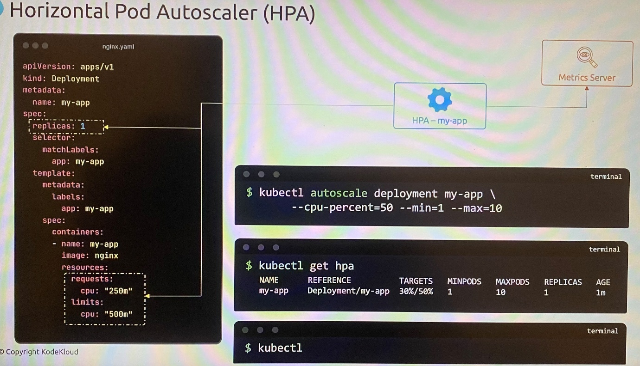

To configure a Horizontal Pod Autoscaler in declarative approach, use these configuration.

API version: autoscaling/v2.

Kind: HorizontalPodAutoscaler

spec.scaleTargetRef: the target resource we want HPA to monitor

spec.minReplicas: minimum number of pods

spec.maxReplicas: maximum number of pods

spec.metrics: the metrics and resources to monitor.

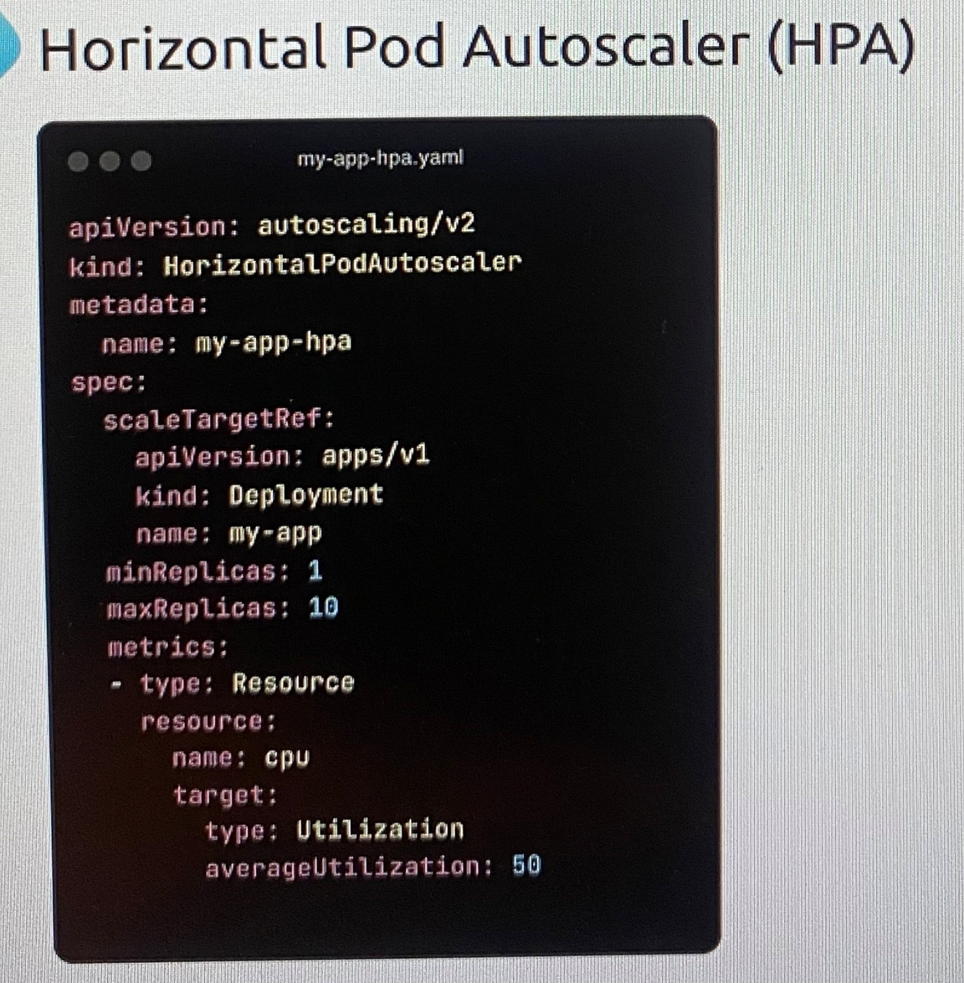

HPA comes built in with Kubernetes since version 1.23. Note that it relies on metrics server so that is a prerequisite.

The **metrics-server** is a cluster-wide aggregator of resource usage data, and it provides the metrics required by the HPA to make scaling decisions.

There is a resource that **custom Metrics Adapter** that can retrieve information from other internal sources like a workload deployed in a cluster.

We can also refer to external sources such as tools or other instances that are outside of the Kubernetes cluster, such as a Datadog or Dynatrace instance using an external adapter.

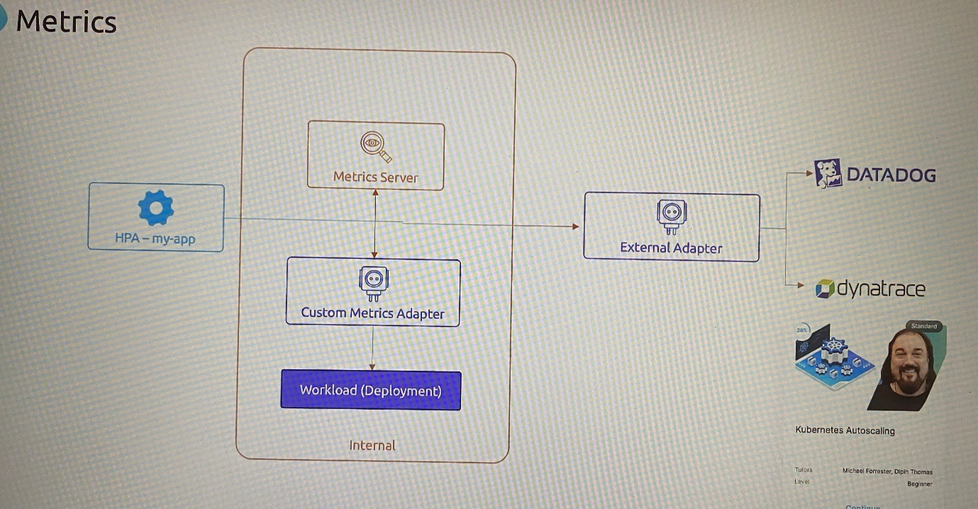

This HPA config change can make a huge difference in scaling.

In Kubernetes, HPA waits for at least 10% change in CPU/memory usage before adding or removing pods.

You cant control how sensitive it was to increase or decrease in usage.

For example,

If you set 70% as the usage target, Kubernetes would only scale up if it went above 77%, and scale down if it went below 63%.

The new alpha feature has a solution for this.

**In-place Resize of Pod Resources**

With Kubernetes version 1.32 has released, if you change resource requirements of a pod in a deployment, the default behaviour is to delete the existing pod and then spin up a new pod in new replica set with the new resource definition.

Hence any changes to the resource definitions on a pod does not happen in place, which means the pod needs to be killed and the new pod with the new resource definitions need to be created. This can be disruptive for stateful workloads. Hence there is an improvement that is called as **in-place resize of pod resources.**

With Kubernetes release 1.27, this feature is not enabled by default. However, it will be enabled when it goes to beta or stable stage in future.

But the feature is still available with feature as part of Kubernetes cluster that must be enabled.

$ FEATURE\_GATES=InPlacePodVerticalScaling=true ; set feature flag to true to enable

Once this feature **InPlacePodVerticalScaling** is enabled, the pod definition supports a set of **resizePolicy** parameters which allows to specify a restart policy for each resource.

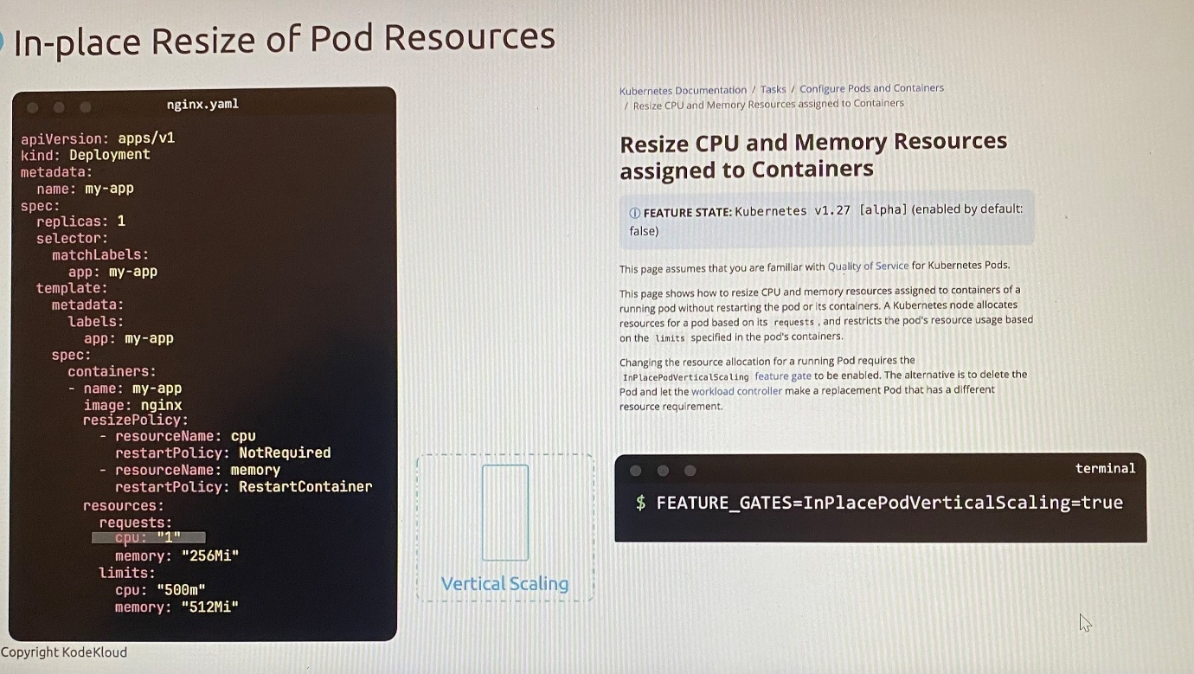

spec:

containers:

- name: my-app

image: nginx

resizePolicy:

- resourceName: cpu

restartPolicy: NotRequired

resourceName: memory

restartPolicy: RestartContainer

We have defined that a change in CPU resource will not require the pod to be restarted, and a change in memory will require a restart of the pod. Then if we make a change to a resource such as updating the CPU and you can see that the pod does not need to be killed. Instead, it can simply be updated with the new resources and so it can just increase in size.

As of release v1.32, this feature is currently in alpha. With release v1.33, this will be a stable feature.

***Limitations***

* + Only CPU and memory resources can be changed
  + Pod QoS Class cannot change
  + Init containers and Ephemeral containers cannot be resized
  + Resource requests and limits cannot be removed once set
  + A container's memory limit may not be reduced below its usage. If a request puts a container in this state, the resize status will remain in InProgress until the desired memory limit becomes feasible
  + Windows pods cannot be resized

**LAB: Horizontal Pod Autoscaler(HPA)**

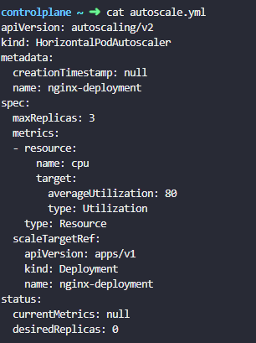



The **HPA status** shows **<unknown>/80** for the **CPU target**. what could be a possible reason?

If the status of the **Horizontal Pod Autoscaler (HPA)** target is <UNKNOWN>/80, it typically means that the HPA is unable to retrieve the **current metrics** for the specified target. Run kubectl describe hpa nginx-deployment to find more details.

In this case, the target deployment doesn't have any resource fields defined where it shows Warning ***FailedGetResourceMetric***

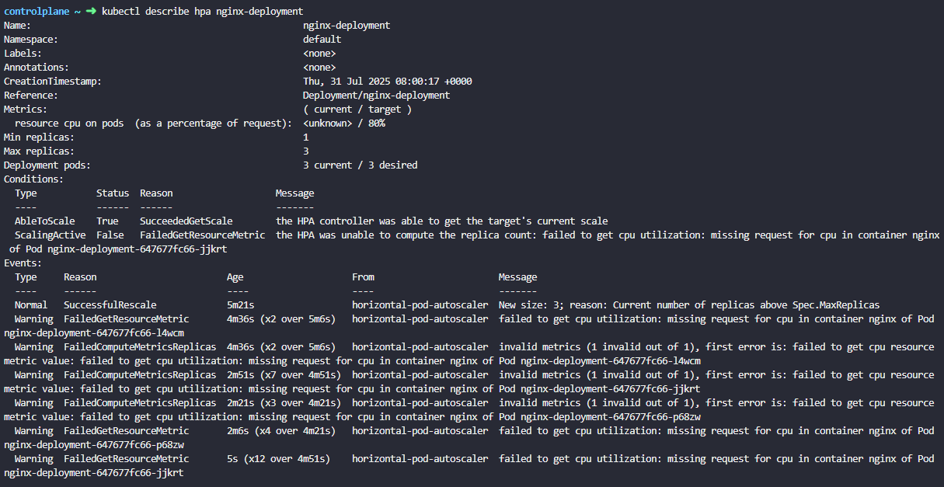

controlplane ~ ➜ kubectl top node

NAME CPU(cores) CPU(%) MEMORY(bytes) MEMORY(%)

controlplane 125m 0% 899Mi 0%

node01 45m 0% 1071Mi 0%

controlplane ~ ➜ kubectl top pods

NAME CPU(cores) MEMORY(bytes)

nginx-deployment-647677fc66-7cc4j 0m 3Mi

nginx-deployment-647677fc66-rcz7l 0m 3Mi

nginx-deployment-647677fc66-z2nl9 0m 4Mi







controlplane ~ ➜ kubectl get hpa --watch

NAME REFERENCE TARGETS MINPODS MAXPODS REPLICAS AGE

nginx-deployment Deployment/nginx-deployment cpu: <unknown>/80% 1 3 3 10m

nginx-deployment Deployment/nginx-deployment cpu: <unknown>/80% 1 3 3 11m

nginx-deployment Deployment/nginx-deployment cpu: <unknown>/80% 1 3 3 12m

nginx-deployment Deployment/nginx-deployment cpu: <unknown>/80% 1 3 3 12m

nginx-deployment Deployment/nginx-deployment cpu: <unknown>/80% 1 3 3 12m

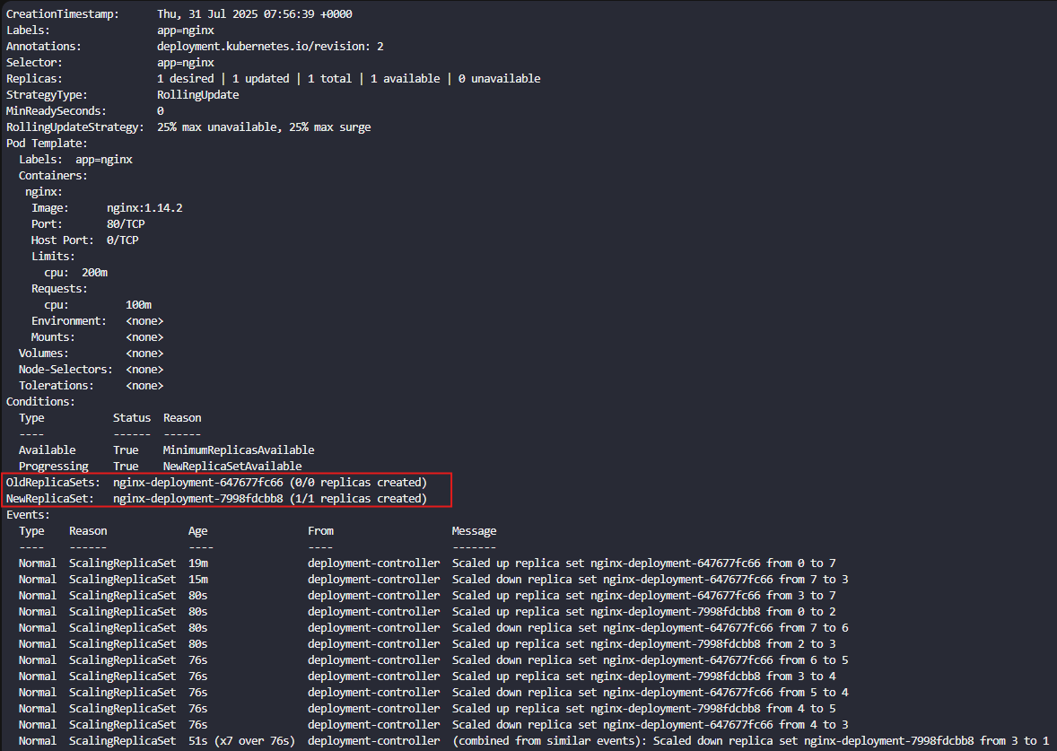

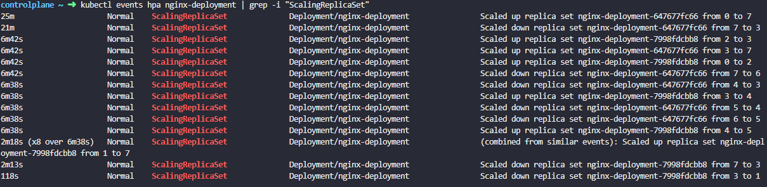

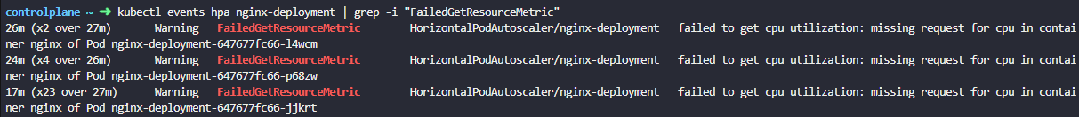

**Vertical Pod Autoscaling(VPA)**

***Scaling resources for a workload the manual way***

In a deployment, resource request and limit are defined. When resource consumption reaches the threshold, we can manually scale the pod vertically by using ***kubectl edit*** command to change the resource request and limit for deployment. Once it saves, then existing pods will be killed and created new pods.

To do automatic scaling workloads vertically, Vertical Pod Autoscaler continuously ***observes metrics*** and then ***adjust resources*** assigned to the pods in a deployment and thus ***balances thresholds***.

Unlike HPA, VPA does not come built-in with Kubernetes, we must deploy it so that we apply the VPA definition file available in the GitHub repo. It deploys multiple components VPA Admission Controller, VPA Recommender, VPA Updater service as pod in kube-system namespace.

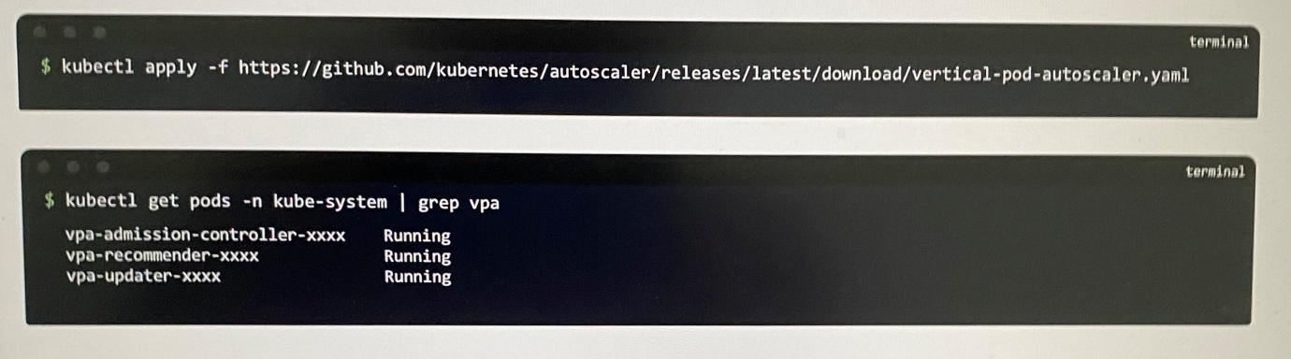

***VPA Recommender*** - continuously monitor resource usage from the Kubernetes metrics API and collects historical and live usage data for pods, and then provides recommendations on optimal CPU and memory values. The Recommender itself does not modify the pod directly. It only suggests changes.

***VPA Updater*** - It gets the information from the VPA Recommender and monitors the pod, then compare collected information with actual pods, then detects pods that are running with suboptimal resources and evicts them when an update is needed.

***VPA Admission Controller*** - intervenes the pod creation process when deployment creates new pod automatically after evicting pods by VPA Updater, and uses the recommendations from the VPA Recommender, then mutate the pod spec to apply the recommended CPU and memory values at startup. It ensures that the newly created pods start with the recommended resource requests.

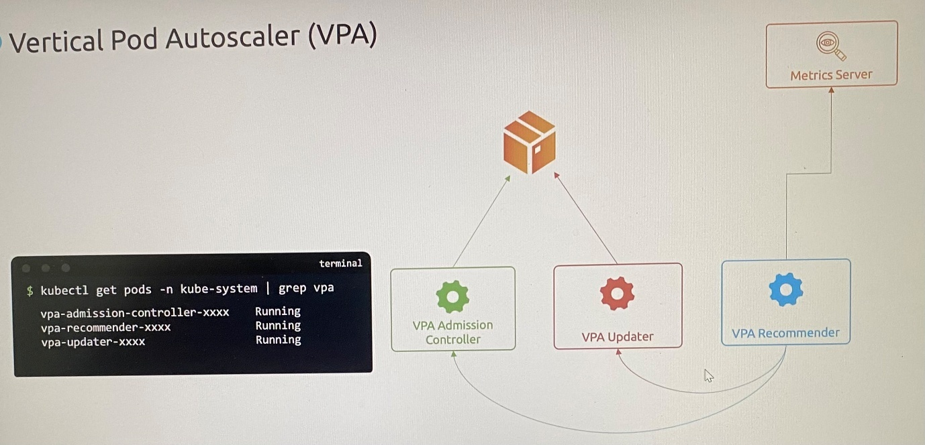

Note that we create VPA using resource definition file. There is no imperative command to create VPA because it is not built-in component line HPA.

To configure a Vertical Pod Autoscaler, use these configuration.

apiVersion: autoscaling.k8s.io/v1

kind: VerticalPodAutoscaler

targetRef: the target resource we want VPA to refer

resourcePolicy>Container Policies: define what container is monitored with CPU minimum allowed and maximum allowed are configured

Update Policy: There are 4 modes that VPA operates in.

***Update policy modes***

**Off** - Only recommends changes but does not change anything where it only the VPA Recommender is working, VPA Admission Controller and VPA Updater are not working

**Initial** - Only changes on pod creation, not later. When deployment scale for some reason, the new pods come up with recommended change from VPA Recommender. VPA Admission Controller intervenes to change pod resource definition. In this case, VPA Updater does not work to evict pods.

**Recreate** - Evicts pods if usage goes beyond range specified. VPA Updater is also working

**Auto** - Updates existing pods to recommended values. For now this behaves similar to Recreate. But when support for "In-place Update of Pod Resources" is available that mode will be preferred over Recreate.

kubectl describe vpa my-app-vpa ; VPA monitor resource usage and suggests adjustments as recommended values

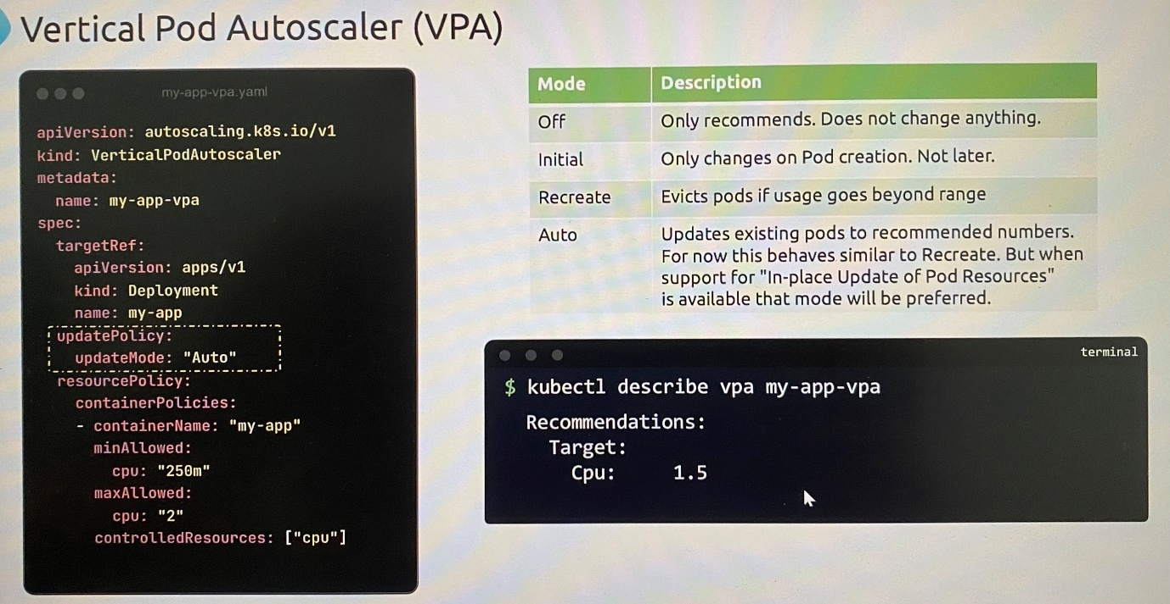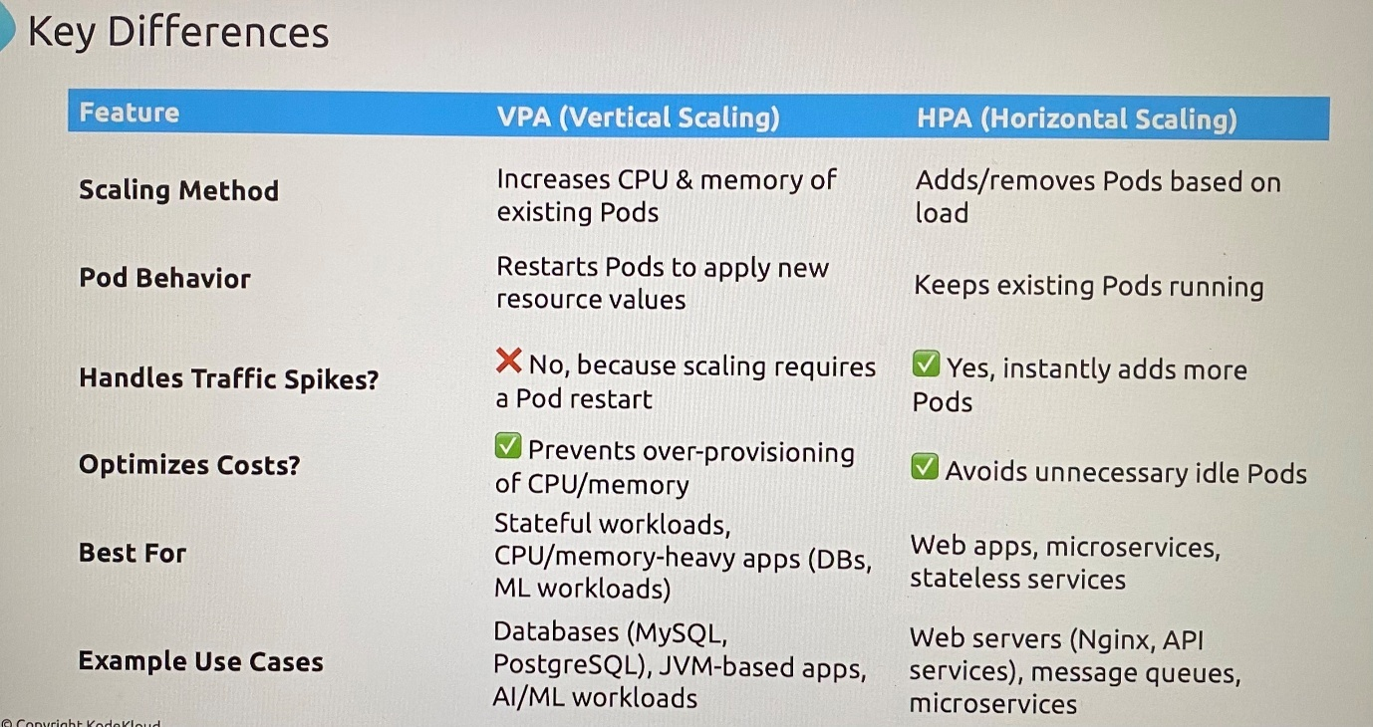

-Considering scaling method, VPA optimizes individual pod performance while HPA focuses on distributing the load across multiple instances.

**LAB: Vertical Pod Autoscaling(VPA)**

Step 1: Install VPA Custom Resource Definitions (CRDs)

These CRDs allow Kubernetes to recognize the custom resources that VPA uses to function properly. To install them, run this command:



Step 2: Install VPA Role-Based Access Control (RBAC)

RBAC ensures that VPA has the appropriate permissions to operate within your Kubernetes cluster. To install the RBAC settings, run:

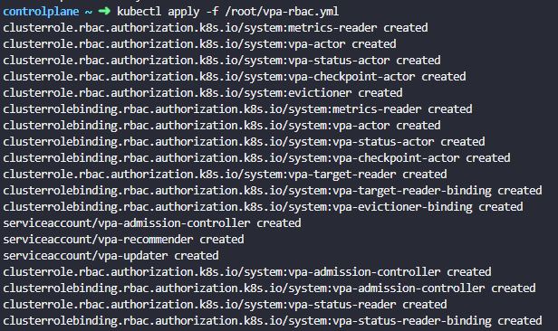

By running these commands, the VPA will be successfully deployed to your cluster, ready to manage and adjust your pod resources dynamically.

**Clone the VPA Repository and Set Up the Vertical Pod Autoscaler**

You are required to clone the Kubernetes Autoscaler repository into the /root directory and set up the Vertical Pod Autoscaler (VPA) by running the provided script.

Steps:

Clone the repository:

First, navigate to the /root directory and clone the repository:

git clone <https://github.com/kubernetes/autoscaler.git>

Navigate to the Vertical Pod Autoscaler directory:

After cloning, move into the vertical-pod-autoscaler directory:

cd autoscaler/vertical-pod-autoscaler

Run the setup script:

Execute the provided script to deploy the Vertical Pod Autoscaler:

./hack/vpa-up.sh

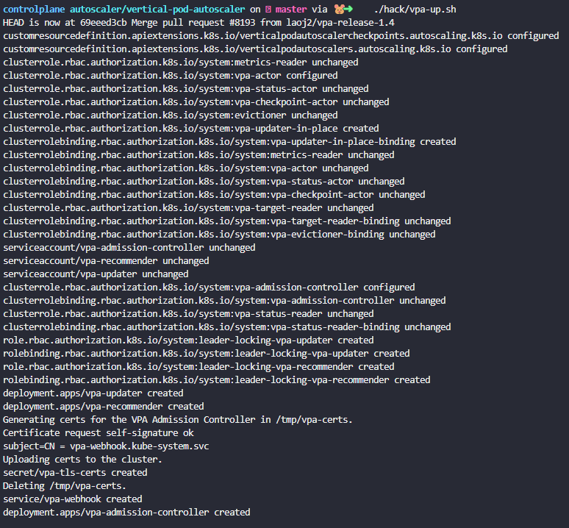

By following these steps, the Vertical Pod Autoscaler will be installed and ready to manage pod resources in your Kubernetes cluster.

It deploys VPA components as deployment.

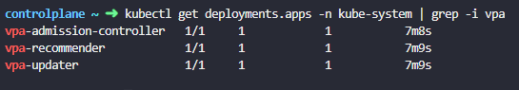

apiVersion: "autoscaling.k8s.io/v1"

kind: VerticalPodAutoscaler

metadata:

name: flask-app

spec:

# recommenders field can be unset when using the default recommender.

# When using an alternative recommender, the alternative recommender's name

# can be specified as the following in a list.

# recommenders:

# - name: 'alternative'

targetRef:

apiVersion: "apps/v1"

kind: Deployment

name: flask-app

updatePolicy:

updateMode: "Recreate"

evictionRequirements:

- resources: ["cpu", "memory"]

changeRequirement: TargetHigherThanRequests

resourcePolicy:

containerPolicies:

- containerName: '\*'

minAllowed:

cpu: 100m

memory: 100Mi

maxAllowed:

cpu: 1

memory: 500Mi

controlledResources: ["cpu", "memory"]

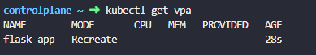

After deployment, check the logs of the Vertical Pod Autoscaler(VPA) updater to ensure it is functioning correctly.

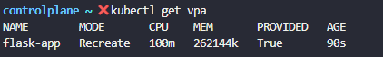

**Interpret VPA recommendations** by understanding key parameters in status section yaml output of VPA like lowerBound, upperBound, and uncappedTarget for resource management.

controlplane ~ ✖ echo "548m" > /root/target

controlplane ~ ➜ kubectl get vpa flask-app -o yaml

apiVersion: autoscaling.k8s.io/v1

kind: VerticalPodAutoscaler

metadata:

creationTimestamp: "2025-08-01T03:45:04Z"

generation: 1

name: flask-app

namespace: default

resourceVersion: "9961"

uid: 2c038f54-c2f8-4c20-972c-7f758f258d5f

spec:

resourcePolicy:

containerPolicies:

- containerName: '\*'

controlledResources:

- cpu

- memory

maxAllowed:

cpu: 1

memory: 500Mi

minAllowed:

cpu: 100m

memory: 100Mi

targetRef:

apiVersion: apps/v1

kind: Deployment

name: flask-app

updatePolicy:

evictionRequirements:

- changeRequirement: TargetHigherThanRequests

resources:

- cpu

- memory

updateMode: Recreate

**status:**

**conditions:**

**- lastTransitionTime: "2025-08-01T03:45:49Z"**

**status: "True"**

**type: RecommendationProvided**

**recommendation:**

**containerRecommendations:**

**- containerName: flask-app**

**lowerBound:**

**cpu: 100m**

**memory: 262144k**

**target:**

**cpu: 100m**

**memory: 262144k**

**uncappedTarget:**

**cpu: 25m**

**memory: 262144k**

**upperBound:**

**cpu: 100m**

**memory: 262144k**

When checking the logs, you see the following error message:

pods\_eviction\_restriction.go:226] \*\*too few replicas\*\* for \*\*ReplicaSet\*\* default/\*\*flask-app-b6c9c4f78\*\*

kubectl logs $(kubectl get pods -n kube-system --no-headers -o custom-columns=":metadata.name" | grep vpa-updater) -n kube-system

This command first retrieves the pod name using kubectl get pods and then pipes it to the kubectl logs command to print the logs of the vpa-updater pod.

controlplane ~ ✖ kubectl logs deployments/vpa-updater -n kube-system | grep -i "pods\_eviction\_restriction.go"

I0405 10:47:59.720755 1 pods\_eviction\_restriction.go:228] "Too few replicas" kind="ReplicaSet" object="default/flask-app-67b666c5fc" livePods=1 requiredPods=2 globalMinReplicas=2

I0405 10:48:59.720842 1 pods\_eviction\_restriction.go:228] "Too few replicas" kind="ReplicaSet" object="default/flask-app-67b666c5fc" livePods=1 requiredPods=2 globalMinReplicas=2

I0405 10:49:59.720666 1 pods\_eviction\_restriction.go:228] "Too few replicas" kind="ReplicaSet" object="default/flask-app-67b666c5fc" livePods=1 requiredPods=2 globalMinReplicas=2

I0405 10:50:59.720880 1 pods\_eviction\_restriction.go:228] "Too few replicas" kind="ReplicaSet" object="default/flask-app-67b666c5fc" livePods=1 requiredPods=2 globalMinReplicas=2

I0405 10:51:59.720601 1 pods\_eviction\_restriction.go:228] "Too few replicas" kind="ReplicaSet" object="default/flask-app-67b666c5fc" livePods=1 requiredPods=2 globalMinReplicas=2

I0405 10:52:59.720972 1 pods\_eviction\_restriction.go:228] "Too few replicas" kind="ReplicaSet" object="default/flask-app-67b666c5fc" livePods=1 requiredPods=2 globalMinReplicas=2

I0405 10:53:59.721156 1 pods\_eviction\_restriction.go:228] "Too few replicas" kind="ReplicaSet" object="default/flask-app-67b666c5fc" livePods=1 requiredPods=2 globalMinReplicas=2

I0405 10:54:59.720820 1 pods\_eviction\_restriction.go:228] "Too few replicas" kind="ReplicaSet" object="default/flask-app-67b666c5fc" livePods=1 requiredPods=2 globalMinReplicas=2

Problem Analysis:

* Flask application is running with only 1 replica pod.
* The Vertical Pod Autoscaler (VPA) needs to evict (remove) the existing pod to create a new one with updated resource settings.
* Kubernetes has a safety feature **pods\_eviction\_restriction.go:226]** that prevents removing the last pod of a deployment to avoid service downtime.
* When you have only 1 replica and VPA tries to evict it, Kubernetes blocks this action with the error message: "too few replicas".
* VPA wants to optimize your pod's resources but cannot because Kubernetes is protecting your service availability.
* As a result, VPA cannot apply its resource recommendations, and application cannot benefit from automatic resource optimization.

Approach to Resolve the Issue:

1. Increase the replica count:

kubectl scale deployment flask-app --replicas=2

2. Verify the Deployment:

kubectl get deployment flask-app -o wide

Ensure that the DESIRED column shows the updated replica count, and the CURRENT column matches the desired number.

3. Check the Pod Status:

kubectl get pods -l app=flask-app

Wait until all pods show Running status.

You should see two pods (or more) in a Running state.

4. Verify VPA operation:

kubectl describe vpa flask-app

This will show the current state of the VPA and any recommendations it has made. If it's working properly, you should see resource recommendations (for CPU and memory) in the output.

With 2 replicas, Kubernetes can safely remove one pod while keeping your application running, allowing VPA to work properly.

controlplane ~ ➜ kubectl describe vpa flask-app

Name: flask-app

Namespace: default

Labels: <none>

Annotations: <none>

API Version: autoscaling.k8s.io/v1

Kind: VerticalPodAutoscaler

Metadata:

Creation Timestamp: 2025-04-05T10:47:22Z

Generation: 1

Resource Version: 4054

UID: e5d1cf06-c58f-4951-a82c-969af94c6631

Spec:

Resource Policy:

Container Policies:

Container Name: \*

Controlled Resources:

cpu

memory

Max Allowed:

Cpu: 1

Memory: 500Mi

Min Allowed:

Cpu: 100m

Memory: 100Mi

Target Ref:

API Version: apps/v1

Kind: Deployment

Name: flask-app

Update Policy:

Eviction Requirements:

Change Requirement: TargetHigherThanRequests

Resources:

cpu

memory

Update Mode: Recreate

Status:

Conditions:

Last Transition Time: 2025-04-05T10:48:00Z

Status: True

Type: RecommendationProvided

Recommendation:

Container Recommendations:

Container Name: flask-app

Lower Bound:

Cpu: 100m

Memory: 262144k

Target:

Cpu: 100m

Memory: 262144k

Uncapped Target:

Cpu: 25m

Memory: 262144k

Upper Bound:

Cpu: 100m

Memory: 262144k

Events:

Type Reason Age From Message

---- ------ ---- ---- -------

Normal EvictedPod 15s vpa-updater VPA Updater evicted Pod flask-app-67b666c5fc-7nsft to apply resource recommendation.

**LAB2: VPA**

In this lab, you will deploy a sample application on Kubernetes, monitor its CPU resource usage, and utilize a Vertical Pod Autoscaler (VPA) to manage and adjust the resource allocation for the pods. The goal is to observe how the VPA automatically recommends and adjusts memory resource limits, particularly when the application experiences increased load.

Objectives:

* Deploy a sample application and verify that the pods are running correctly.
* Monitor pod resource usage using the kubectl top command to assess CPU and memory consumption.
* Deploy a Vertical Pod Autoscaler (VPA) to observe how it adjusts CPU and memory resource recommendations based on the application’s current usage.
* Introduce load to the application and monitor how VPA dynamically updates its recommendations in response to increased demand.
* Interpret VPA recommendations by understanding key parameters like lowerBound, upperBound, and uncappedTarget for resource management.

By the end of this lab, you will have a clear understanding of how VPA optimizes CPU resource usage in a Kubernetes environment, improving application performance and efficiency under varying workloads.